vvv
Chief Executive Officer
Cohuna District Hospital

About Cohuna District Hospital

Our Vision

We are recognised for Excellence in Rural Healthcare

Our Mission

As a healthcare partner we deliver the best of available health and wellbeing services to our community

Our Values

Respect

Integrity

Teamwork

Ethical Behaviour

About Cohuna District Hospital

Located on the banks of the majestic Gunbower Creek, just 10 minutes away from the Murray River and a 45 minute drive from the historic town of Echuca, Cohuna District Hospital (CDH) provides a range of inpatient, aged care and community based services. CDH was established as a public hospital in 1952 and has 16 inpatient beds providing acute medical, surgical and obstetric care for the residents of Cohuna and the surrounding catchment area. CDH also has 16 Residential Aged Care beds and provides community and home based services such as district nursing, planned activity group (PAG), and meals on wheels in conjunction with the Shire of Gannawarra.

CDH is funded by the Victorian Department of Health & Human Services which has allowed the hospital to diversify its services to include a mixture of bed based and community based services. The health service also receives funding directly from the Commonwealth Department of Health & Ageing for residential aged care and community based primary services.

Financial and Service Performance

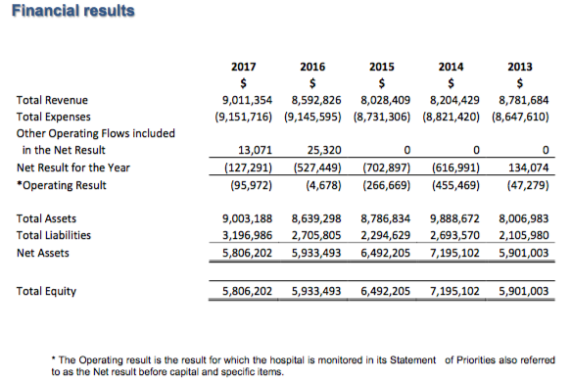

Activity

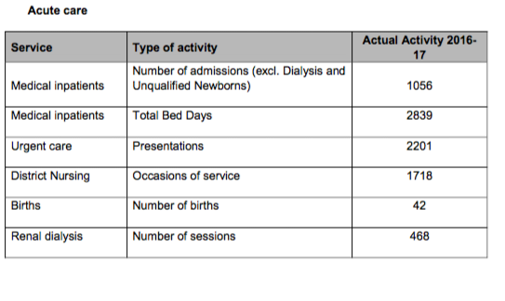

CDH Staffing Profile

Hospitals  Labour Category | June  Current Month FTE* |  | June  YTD FTE*
 | 2016 | 2017 | 2016 | 2017
Nursing /HACC | 36.78 | 37.9 | 36.21 | 35.89
Administration / Quality | 10.62 | 10.31 | 11.01 | 10.53
Hotel Services | 18.95 | 16.58 | 17.90 | 16.03

The FTE figures required in the table above are those excluding overtime. These do not include contracted staff (e.g. Agency nurses, Fee-for-Service Visiting Medical Officers) who are not regarded as employees for this purpose. The above data should be consistent with the information provided in the Minimum Employee Data Set.

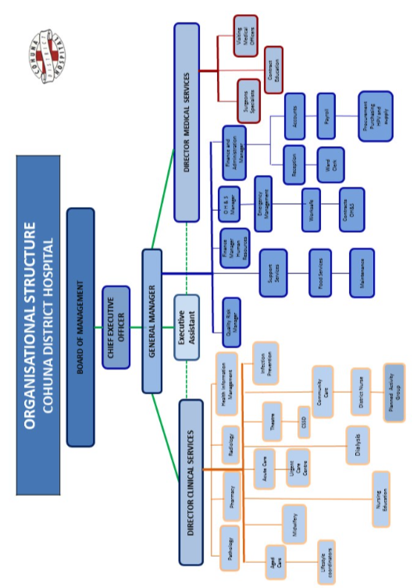

Chief Executive Officer Role

PURPOSE OF THE ROLE

The Chief Executive (CEO) is responsible for implementing the strategic direction of Cohuna District Hospital (CDH) as determined by the Board of Management. CDH must maintain its reputation, meet statutory regulations and comply with the Victorian Department of Health & Human Services (DHHS) policies and procedures.

POSITION SUMMARY

The Chief Executive Officer:

- Is responsible for the operational management of CDH and implements decisions, resolutions and directions of the Board of Management

Ensures that systems and processes are in place to comply with the Health Services Act 1988 and other relevant Acts and Regulations, Hospital By-Laws and all other guidelines, protocols or policies.

- Is the chief point of accountability for patient care and outcomes through effective executive leadership and management of CDH.

- Is accountable to the Board of Management for ensuring that CDH achieves a balance between efficient service delivery and high quality health outcomes, as well as the longer-term planning for improved health outcomes for the Cohuna community.

- Works to advance the objectives of the Heath service and to attain the service objectives in the Health Service Agreement and CDH’s statement of priorities

- Promotes CDH in the communities it serves

Key Selection Criteria

MANDATORY REQUIREMENTS:

KSC 1. Tertiary qualifications in Health Management with relevant postgraduate qualifications are required. A clinical background is highly desirable.

KSC 2. A proven history of executive-level leadership in the health sector that demonstrates achievements in delivering high-quality health services, achieving key performance indicators and achieving budget targets within tight fiscal constraints.

KSC 3. Excellent understanding of principles of evaluation, clinical governance and risk management in a health service as well as a sound understanding of Public Health Governance and experience working with a Board of Management.

KSC 4. Proven workforce leadership abilities including: a demonstrated capacity to motivate, engage, influence and empower employees to maximise their contribution to the health service; holding others to account and being held to account for agreed targets;

KSC 5. Demonstrated ability to clearly communicate vision and future strategy and to ensure the vision is effectively translated into clear business goals and objectives.

KSC 6. Detailed knowledge of the Australian Health Industry and current developments in hospitals, residential aged care, primary health and community service sectors.

KSC 7. Excellent relationship management with internal and external stakeholders and with an ability to develop partnerships and work in the complex governance environment of Health Services in Victoria;

KSC 8. Detailed understanding of hospital funding and service provision including standards for Accreditation and required performance levels;

KSC 9. Understanding of the role of the Health Service in responding to community needs within a rural and regional community.

Remuneration

The Board off Management will negotiate a competitive remuneration package with the successful applicant. A three year GSERP contract with a Total Remuneration Package (TRP) in the range of $134,851 to $211,374. (Group 4 – Small to Medium Rural Centre) will be negotiated with the successful applicant.

The TRP is inclusive of:
- Base Salary
- Superannuation

How to Apply

Applications should include the following information and be emailed to: hrsa@hrsa.com.au
1. Covering Letter
2. Current CV
3. Statement addressing the Key Selection Criteria
4. Completed Application Form (Available on the HRS web site)

Applications Close: March 16, 2018

Further Information
Jo Lowday
Director
0400 158 155

