vvv
Executive Director of Finance & Corporate Services
West Wimmera Health Service

West Wimmera Health Service

Extract from 2016/17 Annual report

West Wimmera Health Service

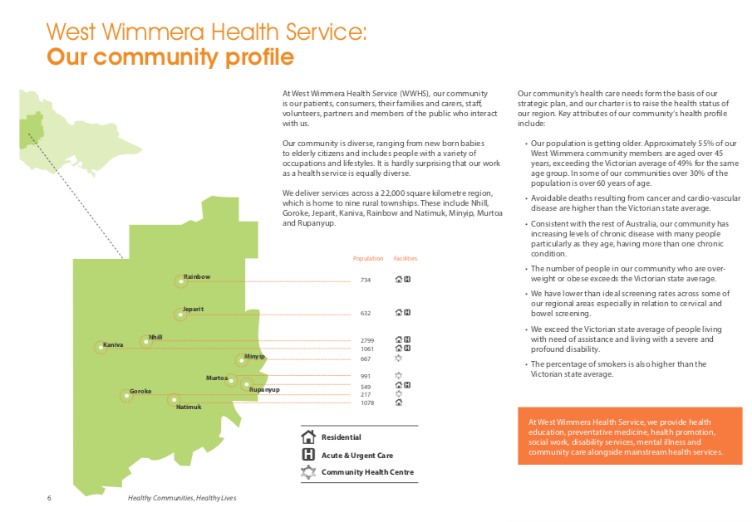

Extract from 2016/17 Annual report

West Wimmera Health Service

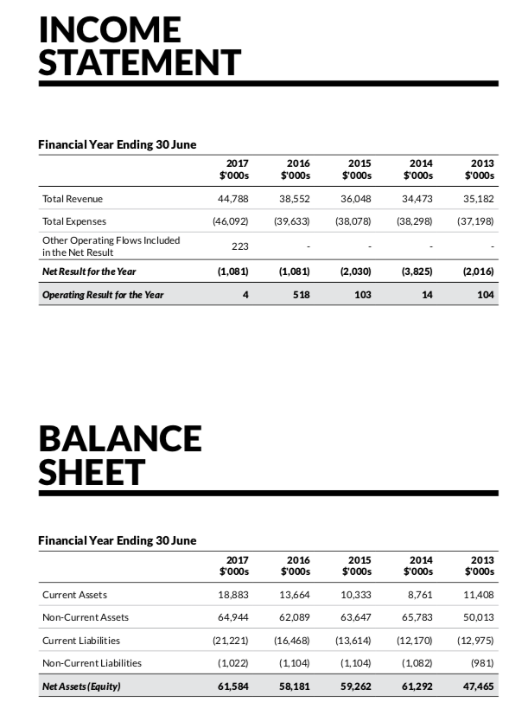

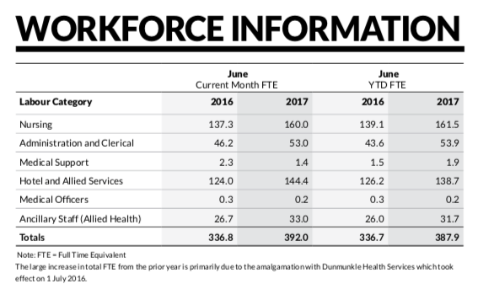

Extract from 2016/17 Annual report

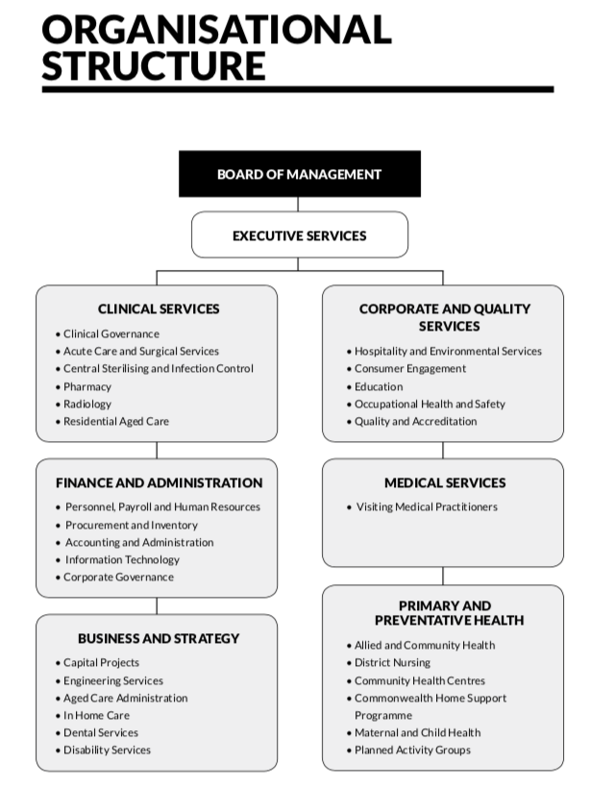

Extract from 2016/17 Annual report – Organisational Structure currently under review.

Executive Director of Finance & Corporate Services

Purpose of the role

The Executive Director of Finance & Corporate Services has functional responsibilities for:

- Financial Management
- Payroll
- Hospitality and Environmental Services
- Procurement
- Administration and Reception Services
- Uniforms
- Volunteers

Key Responsibilities

- The provision of effective, efficient and safe management of the Financial and Corporate Services Division including each of its Departments.

- Maximisation of the Service’s financial capacity to deliver high quality and financially sustainable healthcare services.

- The facilitation of Service-wide compliance with all finance, regulatory and statutory requirements relative to the division

- The development and maintenance of appropriate relationships with internal and external stakeholders

Key Selection Criteria

Mandatory:

- Member of Chartered Accountants Australia & New Zealand or CPA Australia.
- At least 5 years recent experience at senior management level within a hospital / healthcare facility environment.
- Good working knowledge of business and financial management related to health care delivery and administration.
- Demonstrated experience and qualifications in management and leadership.
- Excellent interpersonal, communication and organisational skills.
- Excellent analysis and report writing skills

Remuneration

The CEO will negotiate a competitive remuneration package with the successful applicant. A three year GSERP contract with a Total Remuneration Package (TRP) in the range of $150K will be negotiated with the successful applicant. The TRP is inclusive of:

- Base Salary
- Superannuation 9.5%
- Car

Additional benefits include:
- Salary Packaging available
- Relocation assistance

How to Apply

Applications should include a:

- Covering Letter
- Current CV
- Statement addressing the Position Requirements and Key Selection Criteria; and
- Completed Application Form (available on the HRS web site).

Applications can be lodged online via the HRS web site or by email at hrsa@hrsa.com.au

Applications Close: 4 August, 2018

Further Information

Jo Lowday

Director

Health Recruitment Specialists

0400 158 155

