vvv
Director of Clinical & Aged Care Services
Kilmore & District Hospital.

Kilmore & District Hospital

Our Vision

The community sees the Kilmore & District Hospital and Aged Care Service as the preferred provider and facilitator for its whole of life health related service

Our Mission

The Kilmore & District Hospital and Aged Care Service will provide the community with high quality progressive healthcare and accommodation

Our Values
- Recognition of the dignity, integrity and rights of the individual
- Excellence in all aspects of our work
- Staff commitment and support
- Accountability to all stakeholders
- Visibility in the community
- Co-operation with other health care providers

Kilmore & District Hospital

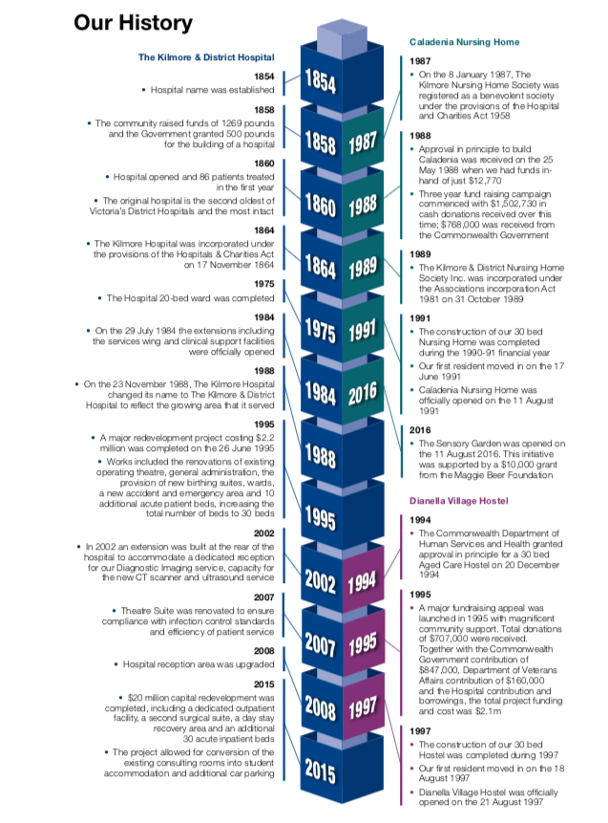

Taken from the K&DH Annual Report 2016/17

Key Statistics

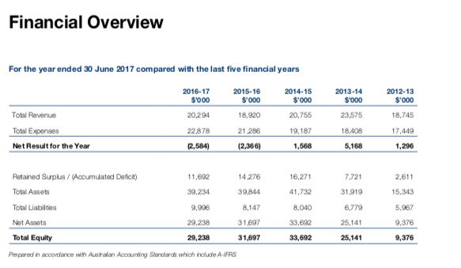

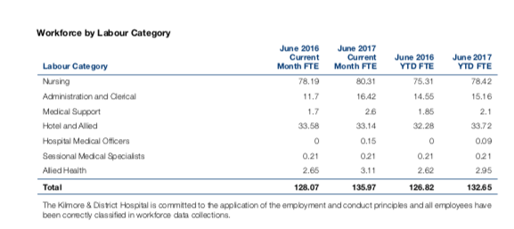

Taken from the K&DH Annual Report 2016/17

Organisational Structure

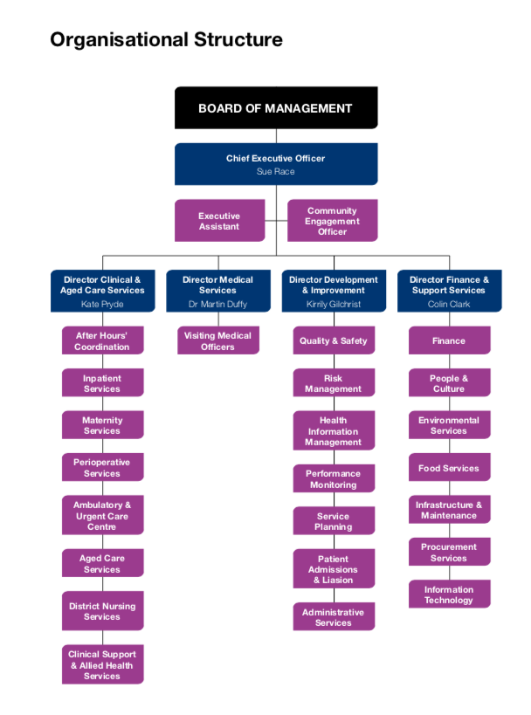

Director of Clinical & Aged Care Services

Position Statement

The primary role of the Director of Clinical and Aged Care Services is to ensure the highest level of clinical services is provided to patients, clients, care recipients and residents at TKDH. This requires the delivery of evidence based, safe and effective clinical care and support.
The Director of Clinical and Aged Care Services is responsible for the domains of acute, aged and midwifery care. As the most senior nurse in the organisation this role also ensures that clinical leadership is established and espouses TKDH vision and values. This role is accountable for the maintenance of professional standards and professional development of nursing and midwifery staff ensuring best practice guidelines and patient centred care philosophies are followed.
The Director of Clinical and Aged Care Services works in close liaison with clinical nursing and midwifery staff, unit managers, visiting medical officers, non-clinical staff and external service providers in the provision of comprehensive patient care services both on and off campus.

Pre-Requisites for the position / Qualifications

Essential
- Registration as a Registered Nurse with the Australian Health Practitioner Regulation Agency (APHRA) and hold a current practicing certificate
- Post graduate qualification in health administration or equivalent (or working towards)
- Probity and clearance required prior to commencement including current Victorian Driver’s Licence, Police and Working with Children Checks
Desirable
- Previous experience at senior management or executive level within the health sector
- Previous experience in a small rural, local or regional health service
- Previous clinical experience in acute (urgent care, medical and/or surgical) or maternity services

Key Selection Criteria

KSC1 | Vision, strong leadership, innovative thinking and a commitment to improving the way services are delivered to patients, clients, care recipients and residents
KSC2 | Demonstrated understanding of contemporary nursing and management theory and practice and current professional nursing and midwifery issues with competence in health care management and industrial relations and their translation into practice
KSC3 | Demonstration of a positive attitude and commitment to the organisation with an understanding of, and ability to integrate, positive organisational behaviours and values
KSC4 | A record of valuing, motivating and developing employees through effective leadership, communication, consultation and development
KSC5 | Able to build rapport and communicate effectively with multi-disciplinary teams and diverse stakeholders, including well developed presentation, negotiation and facilitation skills
KSC6 | Comprehensive understanding of the public health system and hospital operations, priorities, risk management and constraints with demonstrated understanding and knowledge of safety and risk as it pertains to a Small Rural Health Service
KSC7 | Excellent communication (verbal and written) skills including a demonstrated ability to prepare and present briefings and reports using clear and concise language organise information logically and include content appropriate for the purpose
KSC8 | Demonstrated ability in effectively implement quality improvement initiatives, risk management systems, managing projects and leading change within a complex environment
KSC9 | Demonstrated strategic and business planning skills together with advanced analytical capabilities
KSC10 | Commitment to ongoing personal and professional development

Remuneration

The role is full time.

The Total Remuneration Package for the role is $130,000 which is inclusive of your base salary and superannuation at 9.5%. The ability to include a motor vehicle in the package is also an option.

Additional benefits include:

- Salary packaging

How to Apply

Applications should include a:

- Covering Letter
- Current CV
- Statement addressing the Position Requirements and Key Selection Criteria; and
- Completed Application Form (available on the HRS web site).

Applications can be lodged online via the HRS web site or by email at hrsa@hrsa.com.au

Applications Close: 25 July, 2018

Further Information

Jo Lowday

Director

Health Recruitment Specialists

0400 158 157

