Quality Manager
West Wimmera Health Service

West Wimmera Health Service

Extract from 2016/17 Annual report

West Wimmera Health Service

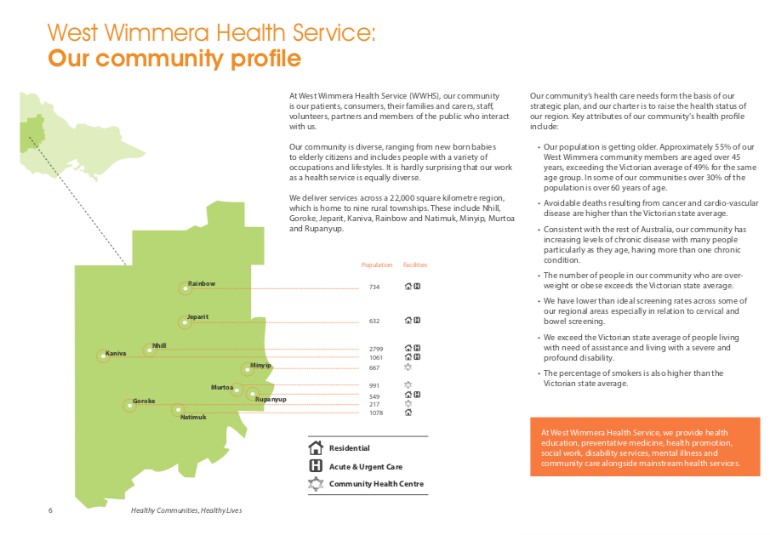

Extract from 2016/17 Annual report

West Wimmera Health Service

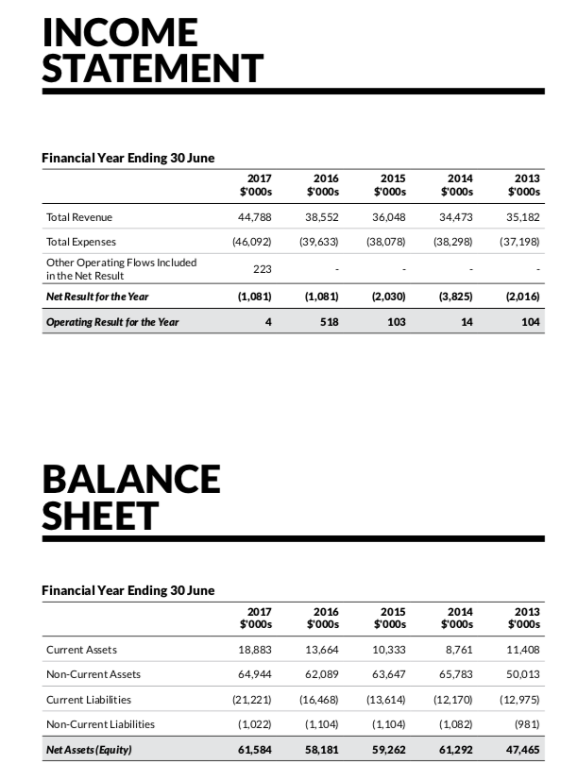

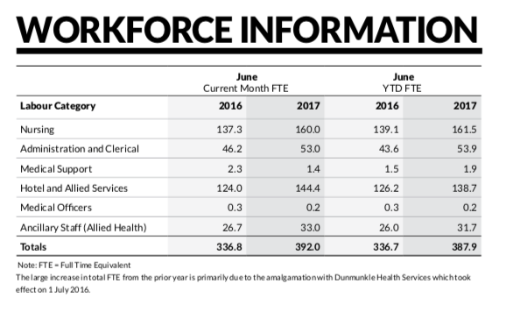

Extract from 2016/17 Annual report

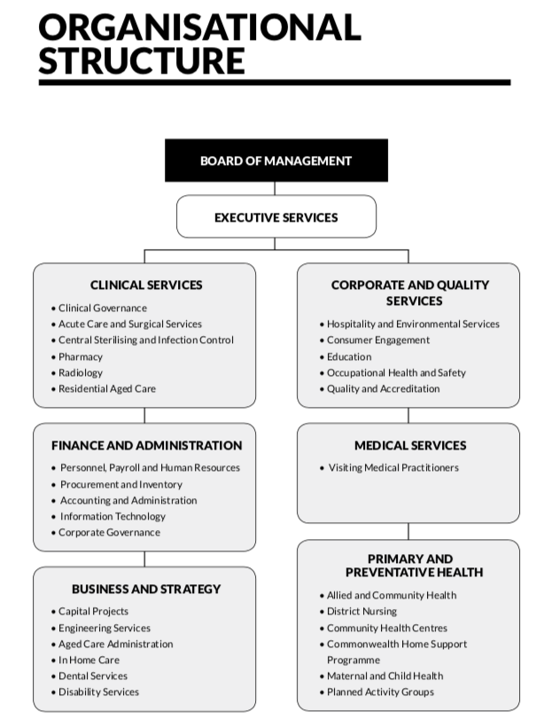

Extract from 2016/17 Annual report – Organisational Structure currently under review.

Quality Manager

Purpose of the role

Reporting to the Executive Director of Quality and Safety the Quality Manager is responsible for coordinating and supporting the Service’s Quality Improvement, Accreditation and Incident Management functions.

Key Responsibilities
- Provide timely, appropriate and responsive coordination of the Service’s Quality Management Framework.

- Coordinate, assist and where appropriate lead the accreditation activities of the service.

- Ensure that quality systems throughout the Service are initiated and monitored in collaboration with the executive management team ensuring positive accreditation outcomes.

- Oversee the development, implementation and review of policies, procedures and protocols pertinent to quality improvement, including accreditation.

- Coordinate the Victorian Health Incident Management System (VHIMS) within the Service and provide timely reports to staff, managers and relevant committees, both internal and external.

Key Selection Criteria

Mandatory:

- Minimum Bachelor’s Degree qualification (AQFLevel7) in a health-related discipline.
- At least 3year’s experience in a quality and safety leadership role.
- Excellent interpersonal skills, with demonstrated ability to interact with all levels across the organisation.
- Exceptional communication skills, especially through the clinical/non-clinical interface.
- Excellent report writing skills.
- Ability to work collaboratively within multidisciplinary teams.
- Ability to collect, analyse and report upon data.
- Ability to accept responsibility and work with limited direction.
- A satisfactory National Police History check.
- A satisfactory Working with Children check.
- Current Victorian driver’s licence.

Desirable Selection Criteria
- Post Graduate qualifications relevant to the role.
- Experience in the Australian Healthcare system particularly in relation to quality improvement and healthcare accreditation with the ability to apply this knowledge.

Remuneration

The role is full time.

The salary for the position is dependent on qualifications and experience and is subject to the relevant Award of each candidate as per the PD

i.e. Health and Allied Services, Managers & Administrative Award 2016-20 or the Nurses and Midwives Enterprise Agreement 2016-20

Additional benefits include:
- Salary Packaging available
- Relocation assistance (up to $2,500)
- Car (private use of a Pool vehicle with the exclusion of periods of leave)

How to Apply

Applications should include a:

- Covering Letter
- Current CV
- Statement addressing the Position Requirements and Key Selection Criteria; and
- Completed Application Form (available on the HRS web site).

Applications can be lodged online via the HRS web site or by email at hrsa@hrsa.com.au

Applications Close: 27 July, 2018

Further Information

Jo Lowday

Director

Health Recruitment Specialists

0400 158 155

