Chief Executive Officer
Goulbourn Valley Health

About Goulburn Valley Health

Goulburn Valley Health (GV Health) is a Regional Public Health Service for the Hume Region of Victoria, with main campuses located at Shepparton, Tatura and Rushworth and additional sites in Shepparton, Seymour, Benalla, Cobram, Echuca and Wodonga. GV Health currently has an annual turnover of more than $278M and staff of more than 2200, and provides a range of acute, mental health, aged and primary health and community support services across the West Hume Sub Region. The main campus in Shepparton is the major acute referral site for the sub region, and is about to commence a $168.5M redevelopment over the next 4 years. GV Health also has external management responsibility for Nathalia District Hospital.

OUR VISION

Healthy communities

OUR MISSION

GV Health is the regional provider of health services. We will:
- Provide the highest quality care and service in the prevention, diagnosis and treatment of injury, disease and other clinical conditions;
- Support integrated health care;
- Drive innovation in healthcare provision;
- Work in partnership with others to promote healthier communities;
- Provide leadership in health care to the region;
- Provide opportunities for teaching, training and research in health care; and
- Attract health care professionals as an employer of choice.

OUR VALUES

Compassion | We are caring and considerate in our dealings with others
Respect | We acknowledge, value and protect the diversity of beliefs, and support the rights of others in delivering health services
Excellence | We act with professionalism to bring the highest quality of health care to meet the needs of our patients
Accountability | We will be responsible for the care and patient outcomes provided by GV Health, and the consequences of our actions
Teamwork | We work constructively and collaboratively within GV Health as well as with external partners to deliver integrated care to our patients
Ethical Behaviour | We act with integrity, professionalism, transparency, honesty and fairness to earn the trust of those we care for

For more information please refer to the GV Health website where you will find publications such as the Annual Report, Quality of Account Report, The Strategic Plan 2014-18.

The Role

The Chief Executive Officer is accountable to ensure that systems and processes are in place to comply with the Health Services Act 1988 and other relevant Acts and Regulations, Hospital By-Laws and all other guidelines, protocols or policies.

Under the direction of the Board of Directors the Chief Executive Officer is responsible to lead GV Health in providing a best practice health service that is of high quality, cost effective and responsive to government policy directions and community needs. The Chief Executive Officer is the single point of accountability for patient safety through effective executive leadership and management of GV Health. The position is accountable to the Board of Directors for ensuring that GV Health achieves a balance between efficient service delivery and high quality health outcomes.

The Board has both a strategic and stewardship role. The functions of the Chief Executive Officer are to manage GV Health in accordance with the financial and business plans, strategies and budgets developed by the Board and the instructions of the Board.

This position amongst others is responsible for promoting GV Health as a quality regional health service provider.

EXTERNAL RELATIONSHIPS:

Liaises with:
- Department of Health and Human Services
- Other health services’ Chief Executive Officers
- Community agencies and representatives
- Accreditation authorities
- Victorian Healthcare Association
- Victorian Hospitals Industrial Association
- Legal and managerial consultants
- Local government organisations
- Tertiary institutions
- Media

INTERNAL RELATIONSHIPS:

Liaises with:
- Executive Staff group
- GVH staff
- Auxiliaries/Volunteers

The Role cont.…

Positions reporting to this role:

- Executive Director Planning and Resources
- Executive Director Clinical Operations
- Executive Director Community and Integrated Care
- Chief Medical Officer
- Executive Director Innovation & Performance/ Chief Nursing and Midwifery Officer
- Director of Community Engagement
- Executive Assistant to the CEO
- Governance and Project Officer

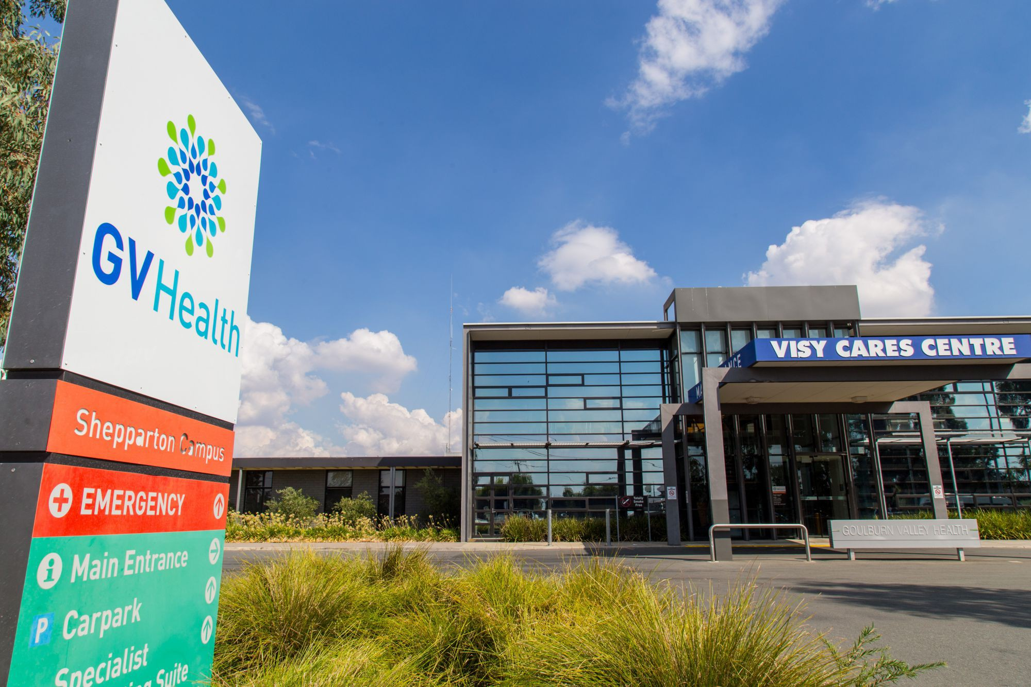

Key Selection Criteria

KEY SELECTION CRITERIA:
(Please respond to this section in your application)

Qualifications

- Possession of tertiary qualifications in commerce, business management or health sciences or similar is essential.
- A post graduate qualification in business administration or other relevant area is highly desirable.

Essential Skills and Attributes

- Demonstrated achievement as a senior level in delivering high quality health services, achieving KPI’s, meeting budget targets and being able to adjust to increasing financial pressure.
- A proven history of high level leadership skills in a complex organisation including:
- Leading change through people
- Holding others to account and being held to account for agreed targets
- Motivating, empowering and influencing others
- Developing collaborative relationships
- Establishing and maintaining effective governance systems
- Demonstrated ability to provide strategic, analytical and innovative skills in management and service delivery.
- Excellent relationship management skills with internal and external stakeholders.
- Demonstrated capacity to motivate, engage and maximise the performance of the Executive Team, stimulate constructive debate and support colleagues in their contribution to and achievement of organisational objectives.
- Demonstrated ability to define and clearly communicate vision and future strategy and to ensure the vision is effectively translated into clear business goals and objectives.
- Ability to identify with the patient experience and factor into all decision making processes.
- Demonstrated ability to lead, manage and take responsibility for a strong safety culture.
- High level of political acumen and an understanding of and ability to work comfortably in the complex governance environment of health services in Victoria.
- Demonstrated ability to think commercially and identify ways to manage growth and contain costs.
- Understanding of all aspects of capital investment in health infrastructure from reviewing existing facilities, identifying and assessing options, business case development, procurement, project management and strategic oversight of delivery.
- Possession of outstanding personal qualities consistent with the GV Health Values, GV Health and Victorian Public Sector Codes of Conduct (or like documents in other organisations) and leadership framework including self-belief, self-awareness, self-management, drive for improvement and personal integrity.
- Satisfactory National Criminal History Record Check prior to commencement of employment. In accordance with the regulatory framework for aged care in the Aged Care Amendment (2008) measures No. 2) Act 2008, this position is identified as a ‘key personnel” position and Police Check Declaration will be required to be made to the Department of Health and Ageing.

Remuneration

The Board off Management will negotiate a competitive remuneration package with the successful applicant. A three (3) year GSERP contract with a Total Remuneration Package (TRP) in the range of $287,227 to $414,691 (Group 2 – Outer Metropolitan / Regional Specialists) will be negotiated with the successful applicant.

The TRP is inclusive of:
- Base Salary
- Superannuation
- Motor vehicle
- Housing
Other benefits:
Salary packaging benefits are also available.

How to Apply

Applications should include a:

- Covering Letter
- Current CV
- Statement addressing the Position Requirements and Key Selection Criteria; and
- Completed Application Form (available on the HRS web site).

Applications can be lodged online via the HRS web site or by email at hrsa@hrsa.com.au

Applications Close: 30 September 2018

Further Information

John Cross

Director

Health Recruitment Specialists

0417 332 598

