Chief Executive Officer
Corryong Health

About Corryong Health

Our Vision

Together, Strengthening the Health of Our Community

Our Mission

Is to promote wellness and health independence by providing quality services to our community and ourselves

Our Values

Respect, care and compassion for our consumers, their families, our community,
carers and staff.

Connection with our community, keeping clients at the centre of what we do.
Innovation and change, continually improving our performance and efficiency and
providing quality outcomes for our clients.

Professionalism and integrity, being open, ethical, fair and honest.

Accountability to our clients, our organisation and each other.

About Corryong Health

Our History

Founded in 1902 as a Victoria Cottage Hospital, Corryong Health is now a highly integrated and considerably larger organisation providing a broad range of hospital, residential aged care, medical and primary and community support services, including a Medical Clinic and Fitness Centre home based CHPS/NDIS services and Retirement Village.

Corryong Health is one of seven Multi-Purpose Services in Victoria, operating an $11M balance budget. With funding from both State and Federal Governments, it is the largest regional employer with a staff of 86+ EFT (139 Full/Part Time and Casual employees), and delivering 35,000+ occasions of service to the local community in 2018.

Situated in the beautiful Upper Murray region Corryong Health’s catchment is comprised of 3,200 people living in a number of relatively isolated rural communities of north east Victoria and the bordering NSW Australian Alpine Region. The nearest regional centre health service is Albury/Wodonga (pop 90,000) which is located 130km or 1+1/2hrs drive to the west

Corryong is the largest centre in the catchment (pop 1,200) and is an aging population. It is well serviced by local Catholic and State Primary Schools, State High School, sporting and service clubs, banks, cafes and local IGA supermarket and shopping centre. Popular activities include, football, cricket, netball, hiking, mountain bike riding, fishing water skiing and you are on the door step of some of NSW Snow Ski fields.

For further information please go to the Corryong Health website – Click on ‘More’ and then ‘Further Information’ for copies of the Annual Report and Quality of Crae report

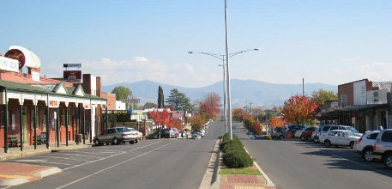

Chief Executive Officer

Purpose of the role / Position Summary
To lead the organisation according to the long term vision, mission and values and objectives defined by the Board of Directors and Health Minister.
Manage and direct the organisation to providing quality, cost effective, patient centred and community responsive health care, through effective use of State and Federal Funding, fee for service and human resources.

For further information please go to the HRS website and download the PD and a copy of the Organisational Structure

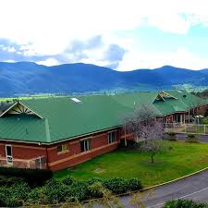

Financials and Workforce Data

Key Selection Criteria
Essential Key Selection Criteria

- Demonstrated competence in leadership and general management at senior levels in the health sector.
- Detailed knowledge of the Australian Health Industry and current developments in MPS, hospitals, residential aged care, primary health and community sectors.
- Understanding of the role of the Health Service in response to community needs within a rural community, demonstrating commitment to community and client participation in population based health planning.
- Demonstrated ability to negotiate, advocate and work with a wide cross section of stakeholders.
- Demonstrated ability to forge useful partnerships with people and organisations across the health, community services and local government sectors.
- Sound understanding of corporate governance and risk management in the health sector.
- Demonstrated financial and business acumen.
- Demonstrated ability to communicate a vision that generates enthusiasm and commitment, align individual and team goals with organisational vision and mission, and develop a culture consistent the organisations values.
- Demonstrated experience of workplace reforms and an awareness of workplace industrial relations within the health sector.
- Demonstrated achievement in the development and implementation of strategic, service and operational plans, and the ability to formulate innovative/entrepreneurial strategies to meet community and health service needs.

Desired Selection Criteria

- Post Graduate Qualifications in Business Management / Health Administration
- Demonstrated ability managing medical staff and experience in supporting and developing medical clinics.
- Demonstrated experience supporting and developing service for CHPS and NDIS markets.
- Innovative and entrepreneurial
- Tertiary qualification in management, health management or related field and evidence of continuing professional development
- Registered Nurse eligible for registration as a Division 1 in Victoria

Remuneration

The Board of Management will negotiate a competitive remuneration package with the successful applicant.

A three year GSERP contract with a Total Remuneration Package (TRP) in the range of $137,548 to $215,601 (Group 4, Cluster 2 – Small to Medium Rural Centre) will be negotiated with the successful applicant.

The TRP is inclusive of:
- Base Salary
- Superannuation
- Motor vehicle
- House

Other benefits:
- Salary packaging available
- Rural & remote housing allowance

How to Apply

Applications should include a:
- Covering Letter
- Current CV
- Statement addressing the KSC
- Completed application form

Applications can be lodged online via the HRS website or by email at hrsa@hrsa.com.au

Applications close: 4 November 2018

Further Information

Jo Lowday

Director

0400158155

