vvv
Nurse Unit Manager-
General Ward

Gippsland Southern Health Service

Our Vision

Excellence in Healthcare

Our Mission

Building a healthier community

Our Values

Individuality

Respect

Accountability

Empowerment

Collaboration

Gippsland Southern Health Service

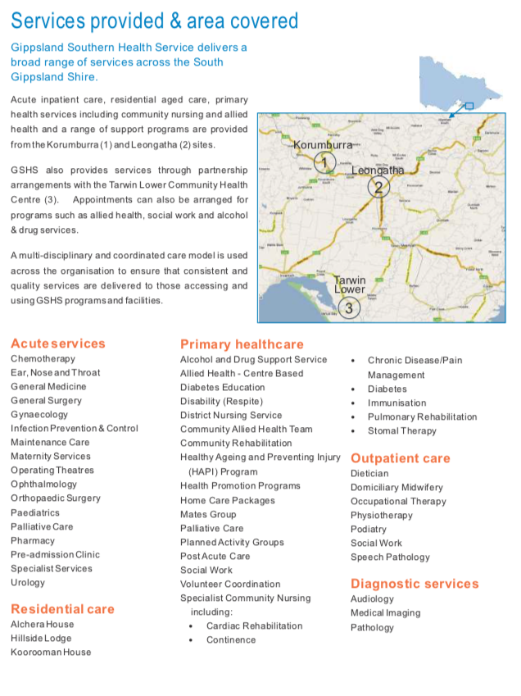

Extract taken from annual report 2016/17 (page 5)

Organisational Structure

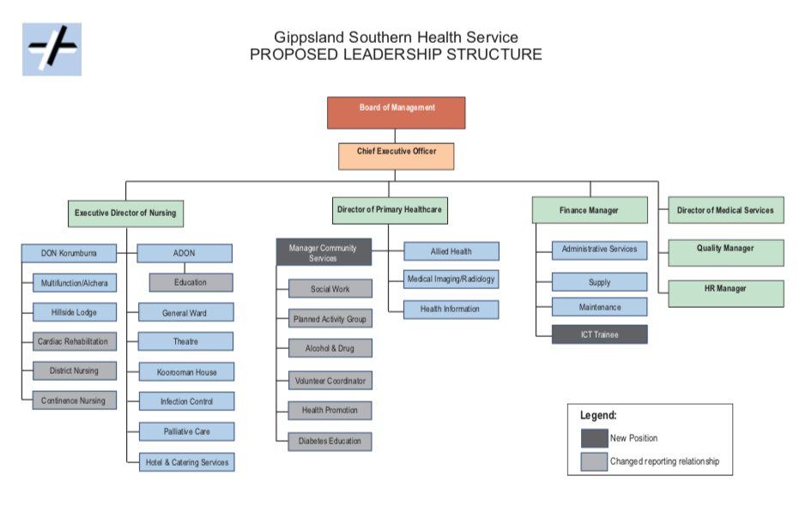

Nurse Unit Manager – General Ward

Position Outline

This primary purpose of this role is to manage the General Ward, consisting of medical, surgical, midwifery and Urgent Care Services. The Nurse Unit Manager has a strong leadership role, exhibiting a keen understanding of the dynamic nature of the health sector and of clinical governance, an ability to instigate change, delegate responsibilities, encourage professional development and enhance the quality of nursing and midwifery practice.

As an integral member of the multidisciplinary team, the NUM works to provide the efficient and effective delivery of professional nursing care to patients in accordance with regulatory requirements.

This objective is achieved by adhering to the following core principles;
- Maintaining professional nursing care for patients and clients;
- Respecting client rights in cooperation with the client, their representatives and other health professionals;
- Ensuring care is provided in accordance with GSHS policies and procedures;
- Ensuring practice is conducted in a way that supports the Occupational Health and Safety principles of GSHS; and
- Providing effective leadership, supervision and clinical support to other care workers.

Key Selection Criteria

Essential:
- Current Registered Nurse with Australian Health Practitioners Regulation Agency
- Current (less than 12 months upon commencement and 3 years thereafter) National Police Records Check
- Demonstrated effectiveness as a Nurse Unit Manager with the ability to lead and manage change in a team environment
- Sound clinical skills and demonstrated application of best practice, contemporary nursing practice
- Minimum of five years’ experience post-graduation, with a minimum 2 years at a Senior Nursing level.
- Current competency in defibrillation, ALS or equivalent

Desirable:

- Working knowledge of relevant funding instruments with demonstrated experience in utilising these to the best advantage of the organisation
- Two years’ experience working at a Nurse Unit Manager level or demonstrated skills in leadership and team work
- Proficient in using computerised systems
- High level of communication and interpersonal skills
- Tertiary qualifications in field of discipline or management/leadership
- Demonstrated knowledge and understanding of quality systems and Health Services accreditations
- Ability to implement management principles and cost effective resource management to a multidisciplinary team

Remuneration

The remuneration package is based on the following classification

Classification | ZH11 –YZ12  Nurses and Midwives (Victorian Public Health Sector) (Single Interest Employers) Enterprise Agreement 2016-2020

The remuneration package includes:

- Base Salary
- Super 9.5%

Other benefits include
- Salary packaging
- Relocation assistance
- Generous professional development support

How to Apply
Applications should include a:

- Covering Letter
- Current CV
- A response to the key selection criteria
- Completed Application Form (available on the HRS web site).

Applications can be lodged online via the HRS web site or by email at hrsa@hrsa.com.au

Applications Close: 9 December, 2018

Further Information

Jo Lowday

Director

Health Recruitment Specialists

0400 158 155

