

Director of Clinical Services

Seymour Health.



**Seymour Health**

**Our Vision**

To be known for quality, integrated community health services that meet the changing community needs

**Our Mission**

Understanding our community – supporting a healthy community by engaging and informing the community in decisions and information about their health

Responsive services – providing local access to quality health services that improve health outcomes

Building Partnerships – developing respectful partnerships that enhance the work of the organisation

Investing in our workplace – supporting staff to provide consistent best quality care for our community

Being sustainable – ensuring that our organisational resources are well managed to provide services into the future

**Our Values**

Respect

Accountability

Honesty, Integrity and Trust

Support

Open and Transparent Communication

**Seymour Health**

Seymour Health is a:

* 30 bed public facility which provides public and private acute medical and surgical, renal dialysis, urgent care, day procedure and palliative care;
* It also has a 30 bed high care aged residential care facility: and
* Community services, including District Nursing, Planned Activity Group,
* Sub-Acute Ambulatory Services including Occupational Therapy, Physiotherapy, Podiatry, Cardiac and Pulmonary rehabilitation, Welfare, Exercise groups, Hospital Admission Risk Program (HARP), Dietician and Diabetes Education.
* Support services including administration, food, hotel and maintenance services.
* Private pathology and medical imaging services are available on site.
* Visiting specialists and local General Practitioners provide the medical services.

Clinical Services

Seymour Health provides a broad range of services including; acute care, palliative care; emergency care; transitional care; renal services; aged care, dental services, community care and primary care services to the community of Seymour and surrounding districts.

The delivery of clinical services is supported by organisational wide services including administration, finance, payroll, food, hotel services and maintenance services.

A number of Quality accreditation standards – NSQHS, Aged Care and Community Care - cover the various program and service areas across the organization. These standards are required to be met by the organization and/or the program area in order for services to

**Seymour Health**

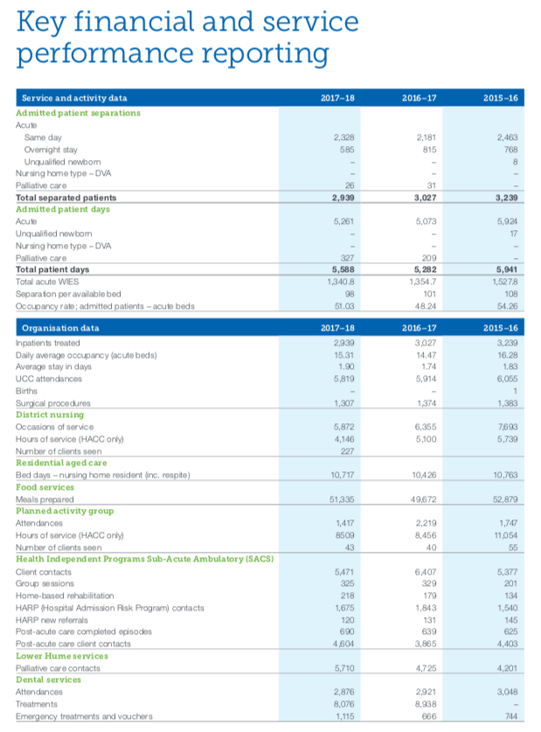

**Organisational Structure**



**Director of Clinical Services**

Purpose of the role

The Director Clinical Services is an executive position providing strategic leadership and oversight for the operations of the clinical services at Seymour Health

The position reports directly to the CEO and is a member of the executive team. The position will be required to support the Board and its sub-committees and provide reports, however this communication can only be done by authority of the CEO

The role of the Director Clinical Services is to:

* Provide strategic leadership to Seymour Health clinical services as detailed in the organisational chart
* Ensure the highest-level clinical care and safety is provided in the clinical service areas
* Strategically manage the performance of the clinical services areas to meet clinical and quality standards including accreditation requirements
* Monitor and report on the overall performance of the clinical program areas and report to the executive, Board and funding bodies as required
* Provide high level leadership and management to program managers to ensure program performance is of the highest standard
* To work in partnership with the executive team to deliver on the strategic priorities of the organization.
* Develop and maintain local sub-regional and regional partnerships and networks to improve service performance and take advantage of potential funding and service growth opportunities

Key Responsibilities

|  |
| --- |
| The Director Clinical Services is responsible for   * Maintaining the highest level of clinical standards and practices to ensure safe patient care * Respond to incidences of clinical care that have compromised, or have had the potential, to compromise patient care * Ensuring that quality standards, quality improvement and accreditation processes are in place to meet all internal and external requirements * Strategically managing the performance of the clinical program areas including performance against funded targets, financial and budget performance, clinical indicators performance and any other key performance measures that may apply from time to time. * Monitoring and reporting on program performance and to take corrective action as required * Ensuring that program areas meet internal and external reporting, accountability and compliance requirements, * Management, monitoring and accountability of managers through regular accountability meetings, supervision and appraisals. * Ensuring that managers have the appropriate support and training for them to perform their roles effectively. * Ensuring that the culture and performance of staff in clinical areas are consistent with organizational values and expectations * Respond to and manage HR/IR issues in the clinical areas as required * Developing and maintaining partnerships with funding bodies and other key service partners * implement the strategic directions of the organization |

**The KSC**

|  |
| --- |
| **Essential:**  **Mandatory**   1. Current APHRA Registration for a Registered Nurse, Division 1   **Demonstrated experience**   1. Clinical leadership and management in a complex environment, preferably in a rural or regional health setting 2. High level understanding of safe patient care with experience in leading and managing the systems and processes to ensure that safe care is provided at all times and across all program areas 3. Understanding of and direct experience in leading quality systems including accreditation and clinical review processes 4. Ability to effectively communicate with internal and external stakeholders to achieve the best outcomes for our services 5. Ability to provide high quality, timely reports to the Board, CEO and external stakeholders 6. Ability to manage resources to achieve the best outcomes for patients, staff and the Organisation 7. Ability to take a pro-active, partnership-based approach to challenges and opportunities   **Desirable:**   1. Post Graduate clinical or management qualifications that would enable the position to provide enhanced clinical and/or management leadership. |

**Remuneration**

The role is full time.

An attractive remuneration package will be negotiated with the successful candidate.

**How to Apply**

Applications should include a:

* Covering Letter that includes a response to the Key Selection Criteria
* Current CV
* Completed Application Form (available on the HRS web site).

Applications can be lodged online via the HRS web site or by email at [hrsa@hrsa.com.au](mailto:hrsa@hrsa.com.au)

**Applications Close: 24 March, 2019**

**Further Information**

Jo Lowday

Director

Health Recruitment Specialists

0400 158 157