vvv
Quality Manager
Lyrebird Villages for the Aged Inc

About Lyrebird Village

Our Vision

To assist people in our care to lead health lives by supporting them to attain their optimal physical, emotional and spiritual wellbeing.

Our Mission

To encourage people in our care to enjoy their lives to the fullest potential

Our Values

Respect – we are committed to equality and value diversity

Innovation – We challenge ourselves to develop new and better ways to deliver quality care and ensure sustainability into the future

Integrity – We manage our community in an ethical and transparent way

Inclusion - We are committed to a culture of teamwork, consultation and collaboration between stakeholders

For additional information about Lyrebird Villages please visit the Health Recruitment Special website and download a copy of the organisation’s Annual Report – www.hrsa.com.au

Organisation Flow Chart

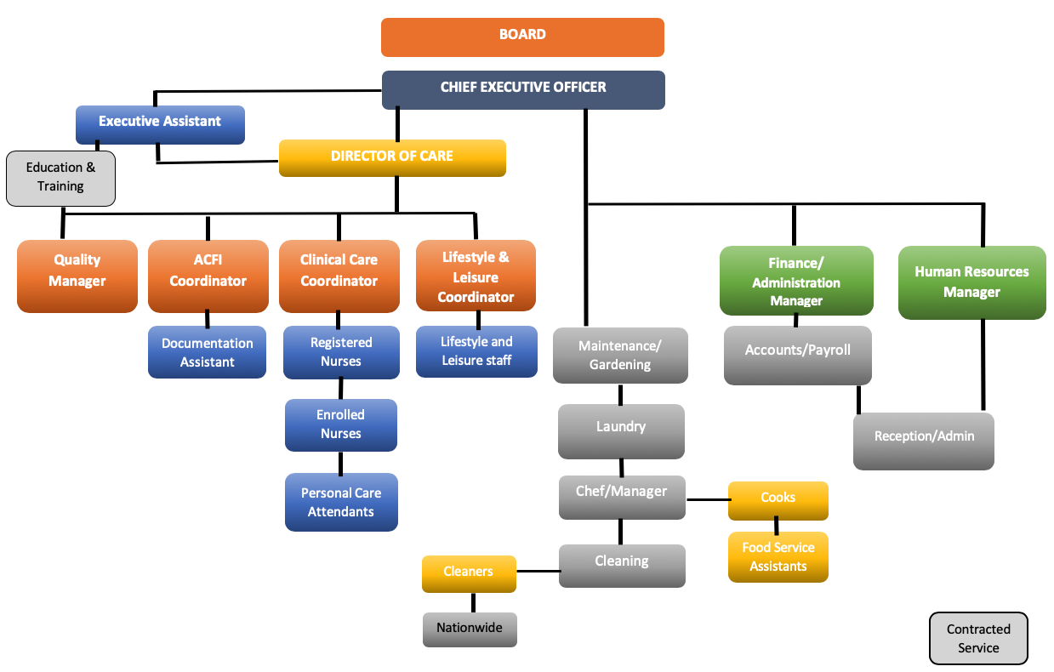

The role – Quality Manager

Position Overview

Building a culture that promotes safety, quality and innovation and fosters a commitment to continuous review and improvement across Lyrebird Village. The role contributes to education and supports the development of local department specific quality improvement plans and activities in alignment with Lyrebird Village’s strategic plan.

The Quality Manager is responsible for oversight of quality improvement programs and quality standards across the organisation ensuring effective management and implementation of continuous improvement plans.

The position works closely with the executive team to ensure delivery and achievement of key strategies in accordance with clinical governance and other relevant standards. The position will implement and maintain a strategic and comprehensive quality system.

It is expected the following functions will be undertaken:

- Maintain Quality and Risk systems including documentation of continuous improvement projects that align with models of care
- analysis of audit tools both internally and externally and development of audit process organisation wide
- assist with maintaining policy/ procedure reviews
- assist with maintaining risk management system
- maintain incident management system
- maintain internal audit system
- participate in the organisation’s feedback system
- preparing reports and supporting the clinical governance committee
- promote the development of strategies to involve consumers and the community in the organization with a particular focus on achieving the standards
- working with Managers to coordinate consumer, staff and other focus surveys
- coordinate consumer focus groups
- participate in clinical reviews and root cause analysis where required
- maintain up to date industry knowledge of legislation, standards and systems.
- Prepare annual Quality and Safety report for the Board

Key Selection Criteria

Qualifications/Skills
Essential:

- An understanding of quality processes including auditing and continuous improvement plans
- Experience with Accreditation processes
- A strong understanding of the needs of elderly persons and good clinical practice within aged care
- Self-motivated with high level of communication, organisational and time management skills.
- A working knowledge of the needs of elderly persons residing with a residential care facility
- Strong written and verbal communication skills.
- Good problem-solving skills
- Advanced computer software skills and experience including word, excel and resident care systems
- Satisfactory National Criminal History Record Check prior to commencement of employment

Desirable:
- Demonstrated commitment to ongoing learning.
- Current registration with AHPRA as a health professional

Remuneration

The role is part time at 0.8 EFT

An attractive remuneration package will be negotiated with the successful candidate.

Other benefits include:

- Salary packaging is available

- Relocation assistance can also be negotiated with the successful candidate

How to Apply

Applications should include a:

- Covering Letter incorporating a response to the Key Selection Criteria;
- Current CV; and
- Completed Application Form (available on the HRS web site).

Applications can be lodged online via the HRS web site or by email at hrsa@hrsa.com.au

Applications Close: 2 June, 2019

Further Information

Jo Lowday

Director

Health Recruitment Specialists

0400 158 155

