Director of Clinical Services
Hesse Rural Health

Hesse Rural Health

Our Mission

Hesse is dedicated to providing and facilitating access to best practice health, aged and community-based services that strive for rural wellbeing.

Our Values

Inclusiveness – Welcoming Everyone

Integrity – Accountable, Transparent Practice

Excellence – Committed to Being the Best We Can

Creativity – Leading into the Future

Person Centred – Finding What’s Important to the Individual

About Hesse Rural Health

Hesse Rural Health (Hesse) is a small rural health service (SRHS) and a key integrated rural health care provider located within the three local government areas of Surf Coast, Colac Otway and Golden Plains. The organisation provides a broad range of services which include: Aged Residential including Dementia Specific Care, Sub-Acute Hospital, Urgent Care, Community Health, Health Promotion, District Nursing, Allied Health, Palliative Care, Home Care Packages, Social Support Programs, Facilitated Play Groups and Occasional Child Care.
Services operate from sites at Winchelsea, Beeac, Rokewood and Bannockburn. Hesse provides a community based, multi-disciplinary team approach to the identified health needs of the population and aims to promote the wellbeing of the rural community it serves.

For more information about the health service please visit their website https://www.hesseruralhealth.net.au/
To access their annual report and strategic plan click on:
About Us and then click on Publications & Media

Organisational Structure

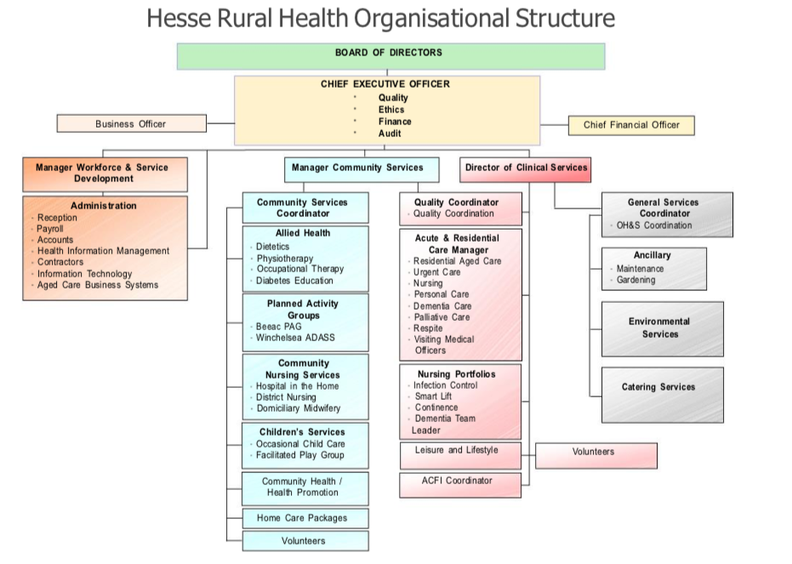

The role – Director of Clinical Services

Position Summary

The Director Clinical Services (DCS) has direct operational responsibility for clinical services provided in Acute, Residential Aged Care, Urgent Care and Palliative Care. The position is accountable for all professional and clinical matters as well as ensuring best practice service delivery. The DCS is an active member of the Executive team and provides effective stakeholder engagement and leadership across the organisation. The role works closely with all other members of the Executive to implement established strategic directions and achieve overall effective and efficient integrated service delivery. The role is pivotal to the development of a compassionate organisational culture that espouses Hesse’s values of Inclusiveness, Person Centeredness, Integrity, Excellence and Creativity.

Key Selection Criteria

Mandatory Requirements
KSC 1. Current Registration as a Registered Division 1 Nurse with the Australian Health Practitioner Regulation Agency (AHPRA)
KSC 2. Relevant tertiary / post graduate qualifications in health service management or advanced clinical practice
KSC 3. Contemporary knowledge and experience in a senior management or executive role in a hospital or residential aged care setting
KSC 4. Demonstrated understanding and experience of clinical governance and application of quality systems that meet externally applied standards such as NSQHS, ACQS or other as relevant
KSC 5. A leadership style that is values driven with a proven ability to develop strong, effective relationships and partnerships with key stakeholders
KSC 6. Demonstrated understanding and application of change management processes
KSC 7. A commitment to consumer centred models of care connecting community and wellbeing
KSC 8. Strategic business leadership skills which includes demonstrated experience in project planning and delivery of intended outcomes
KSC 9. The ability to manage human capital and physical resources within a financial and economic framework
KSC 10. Current Victorian Driver’s Licence

Remuneration

The role is full time with an accrued ADO each 4 weeks.

Remuneration is in line with Victorian Public Sector Nurses and Midwives Enterprise Agreement, and includes a fully supported vehicle and the opportunity to salary package.

How to Apply

Applications should include a:

- Covering Letter that includes a response to the Key Selection Criteria
- Current CV
- Completed Application Form (available on the Health Recruitment Specialist (HRS) website

Applications can be lodged online, via the HRS website or by email at hrsa@hrsa.com.au

Applications Close: 11 August, 2019

Further Information

Jo Lowday

Director

Health Recruitment Specialists

0400 158 157

