Director of Corporate Services
Timboon & District Healthcare Service

About Timboon & District Healthcare Service

Vision

Enabling optimum health and wellness for our communities.

Our Values
Accountability
We show pride, enthusiasm and dedication in everything that we do.
Excellence
We create opportunities for education and are committed to continuous development.
Respect
We consult and collaborate with others and respect the diverse views of our patients, families and each other.
Integrity
We engage others in a respectful, fair and ethical manner.
Compassion
We will accept people as they are and display kindness and sensitivity to them.
Timboon and District Healthcare Service provides:
- a safe, inclusive environment
- quality, person-centred healthcare, disability supports and other community services
and is an Organisation that celebrates the diversity of its communities.

About Timboon & District Healthcare Service

Timboon and District Healthcare Service (TDHS) is a multipurpose service providing a range of health services to the Timboon and surrounding areas. These services ensure optimal health and overall well-being for individuals, allowing them to fully participate in, and contribute to, their community. Located in the picturesque and well-visited western end of the Great Ocean Road, TDHS delivers health services encompassing all needs across the entire community.

Timboon and District Healthcare is at its core, heavily motivated and driven by the community.

Timboon and District Healthcare Service is dedicated to providing optimum health and wellness services in the region, bringing together acute hospital services and the broad spectrum of healthcare services, ranging from aged care to community nursing and education programs.

Acute and residential aged care services are provided within 14 flexible beds
and a 6 day-stay bed complex with an operating theatre suite and urgent care centre. Community Health Services are provided both in house and externally through community outreach programs. Timboon and District Healthcare Service jointly manages the Timboon Medical Clinic which is located adjacent to the Healthcare Service, and contracts General Practitioners as Visiting Medical Officers to the Healthcare Service.

Timboon and District Healthcare Service provides services within the southern half of the Corangamite Shire and the south eastern section of Moyne Shire. Key towns within the catchment area include: Timboon, Cobden, Nullawarre, Peterborough, Port Campbell, Princetown and Simpson.

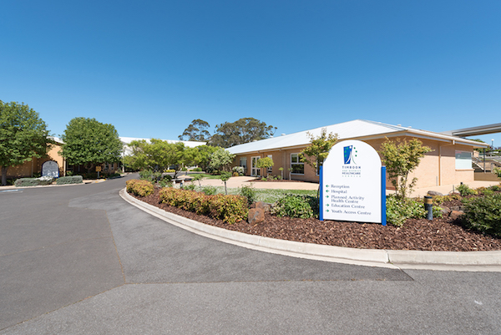

Director of Corporate Services

POSITION SUMMARY

The Director Corporate Services (DCS) reports to the CEO and serves as an integral member of the senior management team.

The DCS provides the leadership, management and vision necessary to ensure the organisational compliance with the proper financial and operational controls, administrative and reporting procedures and has systems in place to effectively grow the organisation and to ensure financial strength and operating efficiency.

The DCS will be responsible for developing, monitoring and evaluating overall corporate strategy with the Chief Executive Officer and leaders of business units with emphasis on triple bottom line performance. This position will provide financial and operational insights to ensure sound professional decisions for formulating and executing strategy.

This role has both a strategic and operational function within Timboon and District Healthcare Service (TDHS). Operationally it is responsible for the financial, administrative and support service functions within TDHS and as such will interact with all departments and staff within the organisation. The DCS is expected to provide leadership to develop a culture that espouses the organisational values of Integrity, Compassion, Accountability, Respect and Excellence. At a strategic level this role oversees organisational financial and corporate statutory compliance and provides timely financial and business advice on which organisational decisions are made. In this capacity the role operates with the Board, Audit Committee and TDHS leadership.

KEY CHALLENGES

- Leading employees to fulfil the vision of Timboon and District Healthcare Service
- Leading and managing a significant number of staff in the provision of safe, contemporary and innovative support services
- Recruitment, retention and professional development of appropriately qualified and experienced staff
- Management of ‘change’ in service delivery and organisational structures to meet future service delivery and organisational development
- Instilling the values of Timboon and District Healthcare Service into all employees work practices and interrelationships

CORE COMPETENCIED

- Proven strong leadership qualities
- Demonstrated high-level strategic, conceptual and analytical skills
- Demonstrated experience in a similar position
- Excellent written and oral communication skills, including the capacity to influence and negotiate in a sensitive and effective manner
- Proven understanding of the application of continuous improvement programs and best practice
- Decision making ability at the Executive level

Key Selection Criteria

- Relevant tertiary qualification in Business Management
- A relevant postgraduate business qualification will be highly regarded as would eligibility for professional membership to a relevant accounting/finance body
- Demonstrated understanding of the funding mechanisms for various health care services and the relevant reporting requirements associated with those funding streams
- Demonstrated experience in the management of corporate support functions and the teams associated with the delivery of these services. Advanced people management skills are a critical requirement of the role.
- Sound knowledge of corporate governance principles including financial management, strategic planning, risk management, contract management, human resource management and continuous quality improvement
- Comprehensive knowledge of key business systems (finance, payroll etc.) and expertise of ICT systems
- Highly developed negotiating, consultancy and interpersonal skills and proven experience in fostering and maintaining partnerships
- High level organisational and communication skills

Remuneration

A competitive three (3) year contract will be negotiated with the successful applicant.

A Total Remuneration Package (TRP) will be negotiable with the successful candidate and is inclusive of:

- Base salary;
- Superannuation;

Additional benefits

- Salary packaging
- Relocation assistance

How to Apply

Applications should include a:

- Covering Letter,
- Current CV
- Statement addressing the Key Selection Criteria; and
- Completed Application Form (available on the HRS web site).

Applications can be lodged online via the HRS web site or by email at: hrsa@hrsa.com.au

Applications Close: 11 December, 2019

Further Information

Jo Lowday

Director

0400 158 155

