Director of Clinical Services

Timboon & District Healthcare Service

About Timboon & District Healthcare Service

Vision

Enabling optimum health and wellness for our communities.

Our Values

Accountability
We show pride, enthusiasm and dedication in everything that we do.
Excellence
We create opportunities for education and are committed to continuous development.
Respect
We consult and collaborate with others and respect the diverse views of our patients, families and each other.
Integrity
We engage others in a respectful, fair and ethical manner.
Compassion
We will accept people as they are and display kindness and sensitivity to them.
Timboon and District Healthcare Service provides:
- a safe, inclusive environment
- quality, person-centred healthcare, disability supports and other community services
and is an Organisation that celebrates the diversity of its communities.

About Timboon & District Healthcare Service

Timboon and District Healthcare Service (TDHS) is a multipurpose service providing a range of health services to the Timboon and surrounding areas. These services ensure optimal health and overall well-being for individuals, allowing them to fully participate in, and contribute to, their community. Located in the picturesque and well-visited western end of the Great Ocean Road, TDHS delivers health services encompassing all needs across the entire community.

Timboon and District Healthcare is at its core, heavily motivated and driven by the community.

Timboon and District Healthcare Service is dedicated to providing optimum health and wellness services in the region, bringing together acute hospital services and the broad spectrum of healthcare services, ranging from aged care to community nursing and education programs.

Acute and residential aged care services are provided within 14 flexible beds
and a 6 day-stay bed complex with an operating theatre suite and urgent care centre. Community Health Services are provided both in house and externally through community outreach programs. Timboon and District Healthcare Service jointly manages the Timboon Medical Clinic which is located adjacent to the Healthcare Service, and contracts General Practitioners as Visiting Medical Officers to the Healthcare Service.

Timboon and District Healthcare Service provides services within the southern half of the Corangamite Shire and the south eastern section of Moyne Shire. Key towns within the catchment area include: Timboon, Cobden, Nullawarre, Peterborough, Port Campbell, Princetown and Simpson.

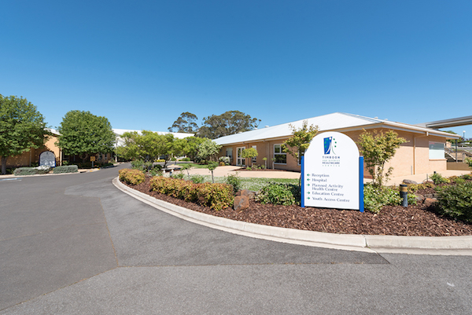

The role

The Director Clinical Services (DCS) reports to the CEO and serves as an integral member of the senior management team.

The DCS has direct operational responsibility for the clinical services provided in the Acute, Residential Aged Care, Operating Suite, Urgent Care, Community Nursing, Community Care and Allied Health units. The position is accountable for all professional and clinical matters as well as the delivery of best practice service delivery.

The role has both a strategic and operational function within Timboon and District Healthcare Service (TDHS). The DCS is an active member of the Executive team and is responsible for providing leadership to the entire organisation. The role works closely with all other members of the Executive to build clear strategic directions and achieve overall efficient and effective service delivery in all services areas. The DCS is expected to provide leadership to develop a culture that espouses the organisational values of Integrity, Compassion, Accountability, Respect and Excellence.

KEY CHALLENGES
- Leading and managing a significant number of clinical staff in the provision of safe, contemporary and innovative care
- Recruitment, retention and professional development of appropriately qualified and experienced clinical staff
- Management of ‘change’ in service delivery and organisational structures to meet future service delivery and organisational development
- Instilling the values of Timboon and District Healthcare Service into all employees work practices and interrelationships
- Leading employees to fulfil the vision of Timboon and District Healthcare Service

CORE COMPETENCIES

- Proven strong leadership qualities
- Demonstrated high-level strategic, conceptual and analytical skills
- Demonstrated clinical experience
- Demonstrated excellent written and oral communication skills, including the capacity to influence and negotiate in a sensitive and effective manner
- Proven understanding of the application of continuous improvement programs and best practice
- Demonstrated decision making abilities at the Executive level

Key Selection Criteria

Qualifications & Experience –

ESSENTIAL
- Registered Nurse with the Nursing and Midwifery Board Australia
- Senior management experience in the health industry
- Significant experience as a professional nursing manager with experience/post graduate qualifications in specialised areas of nursing
- An in-depth and current knowledge of nursing practice, health care issues and management with a proven record in developing, coordinating and working with teams
- Experience at a management level in organisational planning, employee relations and change management.
- Sound understanding of Australian Commission on Safety and Quality in Healthcare NSQHS Standards
- Understanding of AS/NZ 4360 Risk Management, Risk Management Principles and Integrated Risk Management Systems

DESIRABLE
- Experience in a range of specialised areas including Emergency Nursing, Perioperative Nursing and Residential Aged Care
- Post Grad qualifications in Business or Health administration or equivalent tertiary qualification or willing to progress towards same

Remuneration

A competitive three (3) year contract will be negotiated with the successful applicant.

A Total Remuneration Package (TRP) will be negotiable with the successful candidate and is inclusive of:

- Base salary;
- Superannuation;

Additional benefits

- Salary packaging
- Relocation assistance

How to Apply

Applications should include a:

- Covering Letter,
- Current CV
- Statement addressing the Key Selection Criteria; and
- Completed Application Form (available on the HRS web site).

Applications can be lodged online via the HRS web site or by email at: hrsa@hrsa.com.au

Applications Close: 11 December, 2019

Further Information

Jo Lowday

Director

0400 158 155

