Director of Nursing

Illoura - Residential Aged Care

Northeast Health Wangaratta

About Northeast Health Wangaratta

Our Vision
To be recognised leaders in rural healthcare

Our Mission
To provide healthcare that enhances the quality of life of people in North East Victoria

Our Values
Caring, Excellence, Respect, Integrity, Fairness

Northeast Health Wangaratta (NHW) is a very busy specialist referral integrated health service of 241 beds and is the major referral facility for the greater part of North East Victoria. NHW provides a wide range of acute specialist medical and surgical services including; an emergency department, critical care unit, obstetrics and gynaecology, paediatrics and specialised aged care, community rehabilitation, and inpatient, community, aged and psycho-geriatric mental health services. There is also a broad range of community health services and NHW auspices a number of other regional services in post-acute care, palliative care and infection control.
We have almost 1400 employees working across a range of clinical and non-clinical business areas with the largest proportion of these employees from the nursing division. NHW serves a population of approximately 90,000 and has over 19,000 inpatient episodes and 25,546 Emergency Department attendances a year. These numbers are growing.
Wangaratta is a short 3 hour drive to Melbourne and is the gateway to the Victorian Alps where you can enjoy walking, camping and winter sports. The nearest regional airport is 60 mins away connecting you to Sydney and Melbourne, with flights daily. A regional train service to Melbourne operates daily.
A part of NHW, Illoura Residential Aged Care is a first class facility providing a caring environment that is important to the well-being of senior members of our community and their families. Our staff have the skills and experience to deliver a consistently high standard of care and support. This fully accredited purpose built facility is home to 72 residents, including 6 transitional care beds, frail and memory support units. We meet the individual needs of our residents, providing unsurpassed levels of service and care.
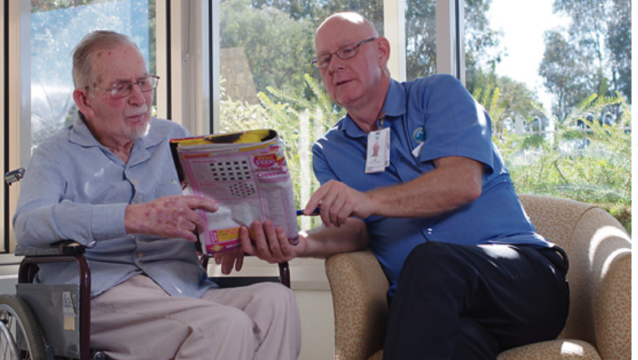

For additional information please refer to the Northeast Health Wangaratta website to view the:
- Financial Performance Report,
- The Quality Account,
- The 2015-20 Strategic Plan
- Hardwiring Excellence at Northeast Health Wangaratta Information Sheet

Director of Nursing: - Illoura Residential Aged Care

POSITION PURPOSE
The primary purpose of the position of Director of Nursing – Residential Aged Care is to ensure the provision of timely, appropriate, responsive and quality driven care through effective resource management and to provide leadership and management to the residential aged care team.

The position will ensure a high standard in all aspects of professional practice and maintain and further develop the quality focus of the service. We seek someone with an absolute passion for caring for vulnerable people, with compassion and empathy.

KEY SELECTION CRITERIA
Essential:
- Hold current registration as a Registered Nurse / Midwife with the Nursing and Midwifery Board of Australia / AHPRA
- Post Graduate Qualifications in Nursing specialty, preferably Aged Care.
- Demonstrated and significant experience at a senior management level preferably in the aged care industry
- Strong, motivating leadership skills, with experience of change management and culture engagement.
- Dedication to excellence in delivery of care and commitment to person centered care
- In depth knowledge of relevant legislation, standards, accreditation framework and policies
- Comprehensive knowledge and experience coordinating a flexible multi skilled team environment with excellent interpersonal, communication and customer skills

All staff must have and remain current for continued employment the following:
- A current National Police Check (renewed every 3 years)
- A current Working with Children Check (renewed every 5 years)
- Statutory Declaration for applicable workers who have lived overseas

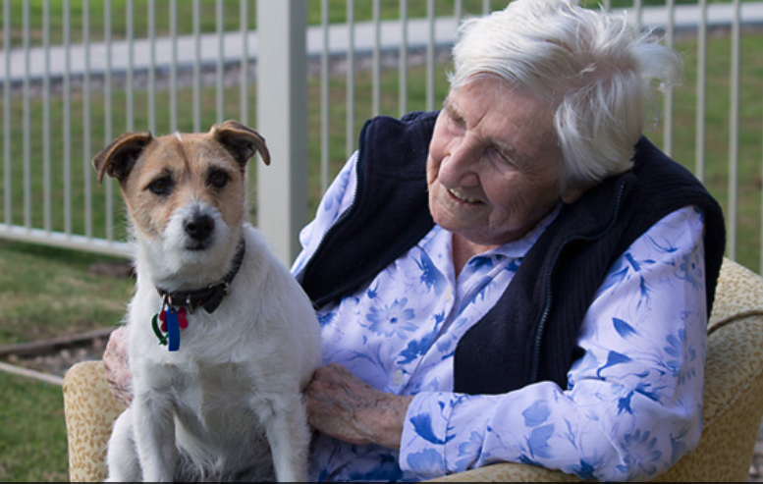

Remuneration

Remuneration is in line with Victorian Public Sector Nurses and Midwives Enterprise Agreement and will be negotiated subject to experience and qualifications.

Other benefits include:
- Salary packaging

How to Apply

Applications should include a:

- Covering Letter that includes a statement addressing the Key Selection Criteria
- Current CV and,
- Completed Application Form (available on the HRS web site).

Applications can be lodged online via the HRS web site or by email at: hrsa@hrsa.com.au

Applications Close: 6 January, 2019

Further Information

Jo Lowday

Director

0400 158 155

