POSITION DESCRIPTION

Position Title: | Director of Nursing – Residential Aged Care
Commencement / Last Date Reviewed: | September 2019
Reviewed By: | Fiona Shanks, Jason O’Keeffe
EBA: | Nursing

ORGANISATIONAL STRUCTURE

Role / Team | Area | Direct Reports
Nursing – Aged Care | Residential Aged Care Illoura | Nurse Unit Managers  After Hours ADON  Lifestyle Team  Administrative staff  Quality Coordinator  ACFI Coordinator  RSA staff  Allied Health Staff  Contractors
EBA Classification | Reports To | Professional Accountability
ZH3 | Director Clinical Services – Nursing & Midwifery | Director Clinical Services – Nursing & Midwifery

OUR VISION

To Be Recognised Leaders In Rural Health Care

OUR VALUES

CARING EXCELLENCE RESPECT INTEGRITY FAIRNESS

POSITION PURPOSE

Northeast Health Wangaratta (NHW) is a busy sub-regional integrated health service of 228 beds and is the major referral facility for the greater part of North East Victoria. NHW provides a wide range of acute specialist medical and surgical services including; an emergency department, critical care unit, obstetrics and gynaecology, paediatrics and specialised aged care, community rehabilitation, and inpatient, community, aged and psycho-geriatric mental health services. There is also a broad range of community health services and NHW auspices a number of other regional services in post-acute care, palliative care and infection control.

A part of NHW, Illoura Residential Aged Care is a first class facility providing a caring environment that is important to the well-being of senior members of our community and their families. Our staff have the skills and experience to deliver a consistently high standard of care and support. This fully accredited purpose built facility is home to 72 residents, including 6 transitional care beds, frail and memory support units. We meet the individual needs of our residents, providing unsurpassed levels of service and care.

The primary purpose of the position of Director of Nursing – Residential Aged Care is to ensure the provision of timely, appropriate, responsive and quality driven care through effective resource management and to provide leadership and management to the residential aged care team.

The position will ensure a high standard in all aspects of professional practice and maintain and further develop the quality focus of the service. We seek someone with an absolute passion for caring for vulnerable people, with compassion and empathy.

RESPONSIBILITIES AND MEASURES OF SUCCESS IN THE ROLE

The following table breaks down the key performance areas of responsibility for the incumbent. Measurements for performance areas will be agreed to with the Reporting Manager.

PERFORMANCE AREA | RESPONSIBILITY
Core Role | - To be the point of contact for the Director Clinical Services – Nursing & Midwifery (DCS) regarding residential aged care issues.  - To represent the Residential Aged Care (RAC) program at appropriate forums.  - To ensure all clinical activity and financial information is tracked and reported monthly and key financial KPI’s are maintained.  - To oversee all retention and recruitment of nursing, lifestyle and administration staff.  - To maintain compliance with the Aged Care Standards.  - To lead, support, embrace and embed Hardwiring Excellence principles and framework in operational strategy.  - To review and implement the operational plan for Illoura, updated every 90 days.  - To contribute to strategic planning pertaining to RAC at NHW.
Leadership and Management | - Functions in accordance with legislation, conducting practice within a professional and ethical framework to deliver accountable care that protects the rights of individuals and groups.  - Effective leadership of Residential Care via strategy formulation and implementation.  - Fulfil the responsibilities of this role in accordance with NHW values and behavioural outcomes.  - Ensures safe practice and good resident outcomes based on currently available best practice and standards.  - Timely notification of issues to the Director Clinical Services and the Executive Team.  - Responsible for the effective day-to-day management of Residential Care.  - Accountable for financial management of the designated cost centres in line with agreed budgetary parameters, level of delegation and performance measures.  - Cultural change towards care of the older person clearly articulated and implemented.  - Increase opportunities for clients and stakeholders to participate in decision making.  - Achieve ACFI target levels each month with timely claims for individual resident funding.  - Marketing strategy developed and implemented each year to maintain 100% occupancy.  - Provide monthly reports on budget performance against operational plan.  - Communicates a clear direction for the facility that is aligned with organisational strategic plan and operational plan.  - Develop systems for monitoring budget each year and production of monthly reports.  - Achieve budget KPI each month.
Human Resources | - Engage the workforce to ensure their behaviours align to the vision, that care models the Studer Hardwiring Excellence principles and organisational best practice.  - Manage work practices in accordance with EBA and legislative requirements.  - Relevant benchmarks for staff management are met for areas including sick leave and staff appraisals.  - Retention of appropriate levels of staff.  - Manage staff recruitment and retention strategies in accordance with NHW policies.  - Ensure annual performance review of all staff is conducted in accordance with NHW policy and achieves 100% compliance.  - Monitor and ensure compliance with mandatory and competency programs and achieve 100% compliance.  - Ensure performance counselling and discipline is managed within NHW framework.

PERFORMANCE AREA | RESPONSIBILITY
Quality and Risk | - Directs the focus of the facility to continuous improvement in service delivery through evidence based practice and the evaluation of changing needs and expectations of residents and families.  - Maintain compliance with the Aged Care Standards and accreditation with Quality & Safety Commission via Quality Improvement Plan that is reviewed quarterly.  - Ensure consistent application of our integrated person-centred approach.  - Analyse services against benchmarks and standards and establish service quality improvement initiatives.  - Prepare for accreditation in an appropriate time frame.  - Compliance achieved with statutory requirements as per Aged Care Act and other relevant Acts such as OH&S.  - Comply with NWH risk management and clinical governance policies and systems.  - Responsible for the development and implementation of the facilities policies and procedures.  - Monitor and review the current management and care information systems and effectively implement improvements where appropriate.
Development and Education | - Foster continuing education and the professional, technical and personal development of staff by facilitating and encouraging staff participation in relevant education programs and tertiary study.  - Staff development plan established each 12 months to ensure residential aged care service staff have appropriate skills for their work.  - Takes responsibility for own professional development.  - Supports succession planning for staff across the facility.
Employee Obligation - OHS | - Participate in the development of a safe and healthy workplace.  - Comply with instructions given for their own safety and health and that of others, in adhering to safe work procedures.  - Co-operate with management in its fulfilment of its legislative obligations.  - Take reasonable care to ensure their own safety and health and that of others, and to abide by their duty of care provided for in the legislation.  - To report any injury, hazard or illness immediately, where practical to their supervisor.  - Not place others at risk by any act or omission.  - Not wilfully or recklessly interfere with safety equipment.

WORKING RELATIONSHIPS

INTERNAL
- Residents (and TCP clients)
- NHW staff
- Illoura staff and volunteers

EXTERNAL
- Residents families and friends
- Professional organisations, LASA and VHA
- Quality & Safety Commission
- Department of Health & Human Services
- Visiting General Practitioners and Specialists

KEY SELECTION CRITERIA
Essential
- Current AHPRA registration as a Registered Nurse
- Post Graduate Qualifications in Nursing specialty, preferably Aged Care.
- Demonstrated and Significant experience at a senior management level in the aged care industry
- Strong, motivating leadership skills, with experience of change management and culture engagement.
- Dedication to excellence in delivery of care and commitment to person centered care
- In depth knowledge of relevant legislation, standards, accreditation framework and policies
- Comprehensive knowledge and experience coordinating a flexible multi skilled team environment with excellent interpersonal, communication and customer skills

All staff must have and remain current for continued employment the following:
- A current National Police Check (renewed every 3 years)
- A current Working with Children Check (renewed every 5 years)
- Statutory Declaration for applicable workers who have lived overseas

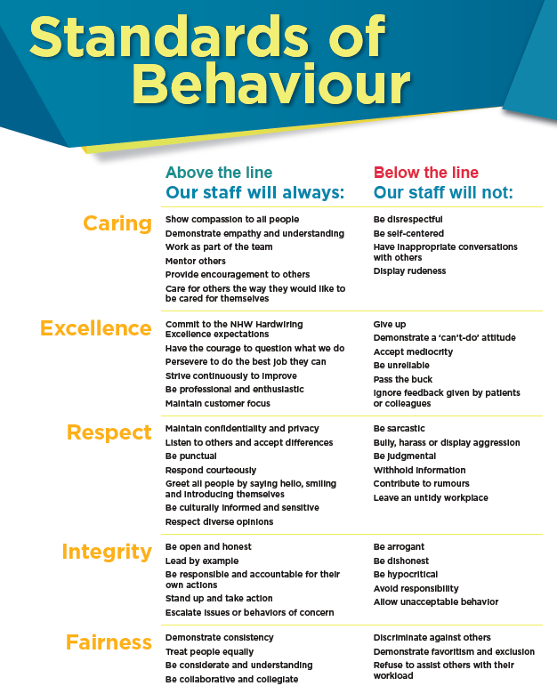

------------------------------------------------------------------------------------------------------------------------------------------------------

Received By Employee

Name:________________________________________________

Date:_________________________________________________

