MUM – Maternity Services

Northeast Health Wangaratta

About Northeast Health Wangaratta

Our Vision
To be recognised leaders in rural healthcare

Our Mission
To provide healthcare that enhances the quality of life of people in North East Victoria

Our Values
Caring, Excellence, Respect, Integrity, Fairness

Northeast Health Wangaratta (NHW) is a very busy specialist referral integrated health service of 241 beds and is the major referral facility for the greater part of North East Victoria.
Our Vision is ‘To be recognised leaders in Rural Health care’. NHW serves a population of approximately 90,000 and has over 19,000 inpatient episodes and 25,546 Emergency Department attendances a year. These numbers are growing.
We have almost 1400 employees working across a range of clinical and non-clinical business areas with the largest proportion of these employees from the nursing division.
Wangaratta is a short 3 hour drive to Melbourne and is the gateway to the Victorian Alps where you can enjoy walking, camping and winter sports. The nearest regional airport is 60 mins away connecting you to Sydney and Melbourne, with flights daily. A regional train service to Melbourne operates daily.

For additional information please refer to the Northeast Health Wangaratta website to view the:
- Financial Performance Report,
- The Quality Account,
- The 2015-20 Strategic Plan
- Hardwiring Excellence at Northeast Health Wangaratta Information Sheet

MUM – Maternity Services

NHW provide a level 4 birthing service to its community and region. The Service is staffed by a dedicated team of midwives, medical specialists and other support staff that are committed to providing the highest standards of care to its community.

NHW also offer a shared care option for low risk mothers known as a caseload model of care. The practice is called the NHW Midwifery Group Practice.

Deliveries | Approx. 700
Birthing Suites | 4
Post-natal beds | 6
Special Care Nursery – level 3 | 6 cots
IT system | BOS
Domiciliary & Antenatal Care | Provided
Lactation Clinic | Yes
EFT | Approx. 34

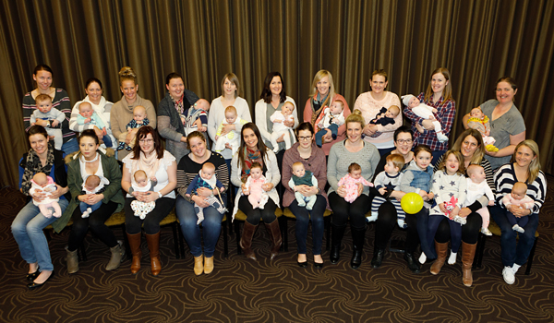

On Friday 4th August 2017 NHW hosted a morning tea with a wonderful group of new mothers who had chosen to have their babies at NHW during the year. The gathering was a celebration of the record number of births but more importantly it provided an opportunity for women to give valuable feedback about the care they received, their reflections about the positive aspects of their care, along with their ideas for possible improvements that could be made. This forum is now an annual event and is integral to leading our improvements in maternity services.

MUM – Maternity Services
ROLE DESCRIPTION
The NUM/MUM provides leadership and management to a multidisciplinary team within a designated ward/unit. The NUM/MUM is responsible for ensuring that clinical practice and delivery of care is consistent with the Nursing and Midwifery Board standards, NHW Nursing & Midwifery Capability Framework domains of practice and NHW values and code of conduct and aligns with the organisational values.
As the NUM/MUM, you are responsible for leading the delivery of comprehensive, safe and evidence-based nursing care to promote optimal health outcomes for all patients within the ward/unit.
KEY SELECTION CRITERIA
Essential:
- Current registration with AHPRA as a Registered Nurse / Midwife
- Demonstrated evidence of post graduate qualifications
- Demonstrated evidence of ongoing personal and professional development
- Ability to meet key accountabilities
- Commitment to leading safe, quality care for Every patient, Every time.
- Demonstarted excellent leadership and management skills
- Demonstrated oral and written interpersonal, communication skills including conflict resolution skills
- Demonstrated evidence of computer and digital competence
- Demonstrated ability to work within a multidisciplinary team and autonomously
- Ability to work well under pressure and flexibiltiy to adapt to changing priorities
- Demonstrated excellent time management, decision making and organisation skills
Desirable:
- Masters or demonstrated willingness to work
- Previous experience in clinical area
- Extensive years of nursing experience including leadership and management roles
Additional Requirements:
- Significant experience in maternity nursing.
  - Maintain a current national Police Check (requires renewal every three years)
- Maintain a current Working with Children check (requires renewal every 5 years)
- Provide and maintain required immunization and serology records - Vaccination category A

Remuneration

Remuneration is in line with Victorian Public Sector Nurses and Midwives Enterprise Agreement 2016-20. Classification NM11

Other benefits include
- Salary packaging

How to Apply

Applications should include a:

- Covering Letter with a statement addressing the key selection criteria,
- Current CV
- Completed Application Form (available on the HRS web site).

Applications can be lodged online via the HRS web site or by email at: hrsa@hrsa.com.au

Applications Close: 16 February, 2020

Further Information

Jo Lowday

Director

0400 158 155

