Chief Executive Officer
Heywood Rural Health

Heywood Rural Health

VISION
Heywood Rural Health is committed to the Health and wellbeing of our community.
Our Values
Respect
- We make mutual respect the basis of all interactions
- We respect diversity and respect the dignity of each person!
- We embrace the differences in people and perspectives
Responsiveness
- We take actions and opportunities to create results
- We provide services that are person centred and focused on outcomes
- We keep our commitments and promises
Care
- We care about the people and the community within which we work and live
- We care about our colleagues and ourselves
- We support people to develop and build on their strengths
Integrity
- We uphold our professional ethic at all times
- We are honest and fulfil our commitments
- We are accountable for our actions

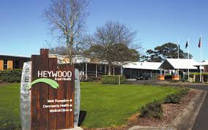

Heywood Rural Health

Heywood Rural Health is situated in the town of Heywood, in the Glenelg Shire in the Western District of Victoria and falls within the Barwon Southwest Region of the Department of Health and Human Services.

In the 2016 Census, there were 1,726 people in Heywood. Of these 49.5% were male and 50.5% were female. Aboriginal and/or Torres Strait Islander people made up 7.7% of the population.
The most common ancestries in Heywood were Australian 35.7%, English 31.6%, Scottish 7.7%, Irish 6.4% and German 3.1%. Current statistics indicate 84.3% of people were born in Australia.
The most common countries of birth were England 2.1%, New Zealand 2.0%, Netherlands 0.9%, Philippines 0.5% and Scotland 0.3%.

Heywood’s service catchment area is identified as Heywood and the surrounding district that is served by Heywood Rural Health, including Dartmoor, Casterton, and Merino. Each of these towns have small populations and are relatively isolated from main stream services.

At Heywood Rural Health, we have Aged Care residents; 45 beds, comprising a combination of high and low care we and we have acute inpatients; 5 beds. We also have a Community Health Service hub, which includes a medical clinic, allied health and community nursing services, home care, meals on wheels and community transport support.

Heywood Rural Health is well supported by residents’ families, staff and volunteers and the wider community. Our vision is to continue working with our community to create a positive enriched caring environment.

Heywood Rural Health has been providing health services to our community from this site since 1957, when a six-bed hospital was established to provide invaluable quality health care. The hospital continued to expand its services to include additional residential aged care beds. Today, Heywood Rural Health supports a workforce of approximately 130 employees, adding to the diversity of services we provide to our community. Our facility is funded by the Victorian Department of Health and Human Services under the Small Rural Health Services flexible funding model. In addition to funding received from the State, we receive funding from the Commonwealth Department of Social Services for aged residential care and community based services.

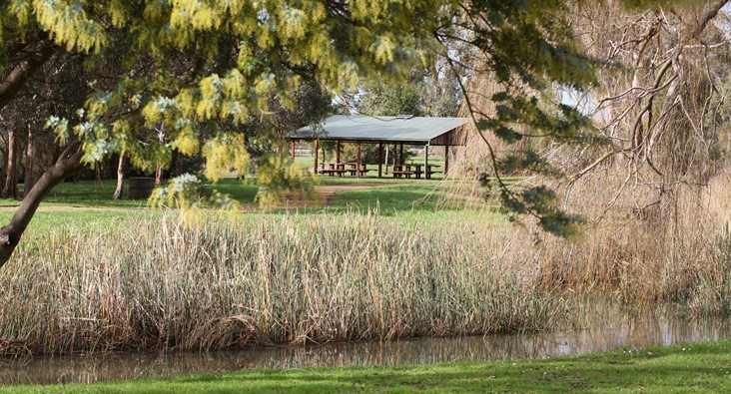

Heywood Rural Health

We provide the following services to our community.

Residential Aged Care
- Residential care
- Respite high / low care
- Palliative Care

Acute Care
- Urgent Care Service
- Post-Acute Care
- Palliative Care

Primary and Community Health
- GP service
- Royal Flying Doctor Service
- Physiotherapy
- HACC
- Home Care Packages
- Occupational Therapy
- Dietetics
- Diabetes Education
- Health Promotion
- Community Nursing
- District Nursing
- Australian Hearing Service

Support Program/ Services
- Volunteer Program
- Meals on Wheels
- Active Program
- Eating with Friends
- Men’s Shed Health Forums
- Aged Care Activities
- Delta Dogs

Heywood Rural Health

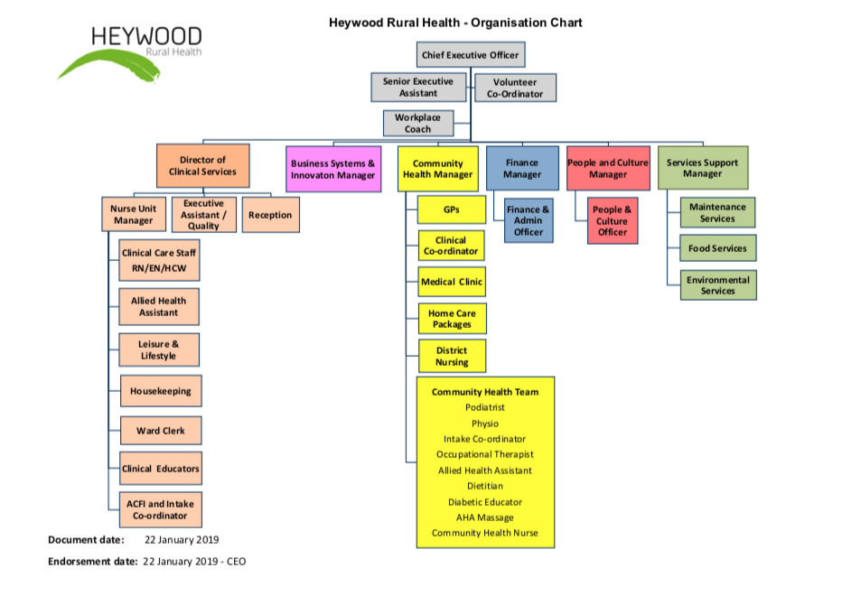

Financials

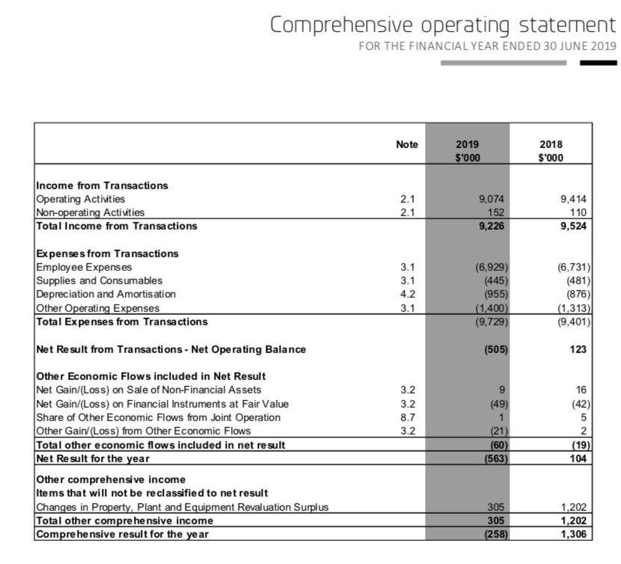

For more information please refer to the 2018/19 Annual Report

Chief Executive Officer

Position Summary

The Chief Executive Officer is responsible, directly to the Board, for the total operational and financial performance of the Health Service and for compliance with its legal and statutory obligations. The position works in collaboration with the Board to set goals for the organisation and is responsible for:

- Human Resource Management - Lead, build and develop staff to ensure a focused and viable health service which meets the aged care, acute and primary health needs of the community.

- Financial Management - Manage the financial resources of the health service in an optimal manner to ensure a sustainable financial base to deliver health and corporate services.

- Resource Management - Manage the physical infrastructure and resources to ensure all services are delivered effectively and efficiently. Responsible for the procurement governance framework.

- Strategic Planning - Deliver against the Board's strategic objectives for HRH.

- Quality and Risk Management - Ensure policies, processes and protocols are in place to meet National Safety Quality Health Service Standards.

- Governance – Ensure compliance with Statutory and Legislative requirements applicable to HRH.

- Community and Public Relations - Develop and support productive relationships with the community, Government and key stakeholders.

Key Selection Criteria
- Tertiary qualifications in health, business management or commerce (preferably with post-graduate qualifications in health, health management or a business related field).

- Extensive leadership and senior management experience and demonstrated skills in the health sector with a proven ability to successfully lead organisational change, manage and motivate staff, promote the creation of a positive workplace culture, lead and manage compliance and develop teams of high performers.

- A track record of success in the financial management of a health service and capacity to deliver strategic outcomes to a budget, combined with the operational ability to maximise an ongoing balanced financial position.

- Demonstrated understanding of the health service industry, experience of Commonwealth and State health policies and programs and a detailed familiarity with Commonwealth and State health funding systems. This will include a demonstrated capacity to deal effectively with the State government and a high ability to work comfortably in the complex governance environment of Health Services in Victoria and an understanding of Federal government processes.

- Excellent understanding of principles of evaluation, clinical governance and risk management in a health service as well as a sound understanding of Public Health Governance and experience working with a Board of Management.

- Ability to negotiate, advocate and work with a wide cross section of stakeholders in responding to health needs within a rural and regional community with established track record that demonstrates excellent relationship management.

Remuneration

The Board of Management will negotiate a competitive remuneration package with the successful applicant. A three (3) year Public Health Service/Hospital Chief Executive Officer contract with a Total Remuneration Package (TRP) in the range of $125,539 to $219,913 (Group 4, Cluster 1) will be negotiated with the successful applicant.

The TRP is inclusive of:
- Base Salary
- Superannuation
- Motor vehicle

Other benefits:

Salary packaging available

How to Apply

Applications should include a:

- Covering Letter that includes a response to the Key Selection Criteria
- Current CV
- Completed Application Form (available on the HRS web site).

Applications can be lodged online via the HRS web site or by email at hrsa@hrsa.com.au

Applications Close: 5 July 2020

Further Information

Jo Lowday

Director

Health Recruitment Specialists

0400 158 155

