Executive Director of Clinical Services

West Wimmera Health Service

West Wimmera Health Service

Our Vision

To pursue excellence in healthcare services by working collaboratively with our partners and embracing innovation and technology

Our Mission

West Wimmera Health Service is committed to the delivery of health, welfare and disability services which are compassionate, responsive, accessible and accountable to individual and community needs, which results in quality outcomes for the people of the West Wimmera, and Southern Mallee.

Our Values

Total Care – delivering care that is safe, effective and person-centred, always
- We are privileged to serve in the care of others.
- We put those we care for, and those around them, at the centre of everything we do.
- We actively listen, pay attention to detail, and respond without delay.
- We bring our best every day to help people live their best lives.
- We care with compassion, dignity and respect.

Safety – providing a safe workplace and services free from avoidable harm
- The physical and mental health of ourselves and those entrusted to our care is paramount.
- We take reasonable care of the safety of ourselves and those around us.
- We learn from our mistakes as well as our successes.
- We don’t take shortcuts and near enough is never good enough.

Unity – working well together in a great place to work
- Everyone contributes, everyone belongs.
- We nurture and maintain safe space for two-way communication.
- We pitch in and help and we’re happy to share credit for a job well done.
- Our diversity makes us stronger.

Accountability – doing the right thing by our stakeholders and ourselves
- We own our decisions and take responsibility for our actions.
- We seek and provide honest feedback and say what we mean.
- We get to the point and deal with issues directly and openly.
- We identify and manage risk to our advantage.
- We avoid waste and favour outcomes that will endure for the long term.

Innovation – using our imagination – if there’s a better way we will find it
- We embrace change as an opportunity to learn and grow.
- We are keen to learn and we generously share our knowledge and experience.
- We’re curious and take time to think how things might be done better.
- We actively involve our partners in our unending quest to improve.
- We aim for simplicity and persist until we understand.

West Wimmera Health Service

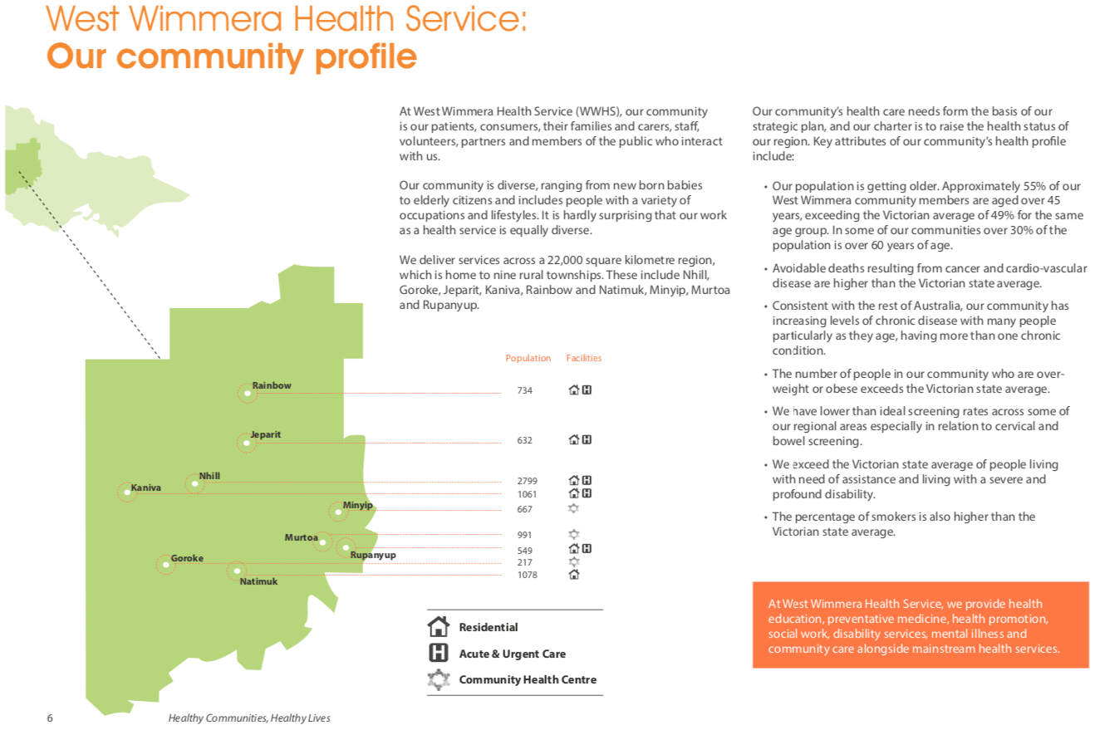

Extract from 2017/18-2021/22 WWHS Strategic Plan

West Wimmera Health Service

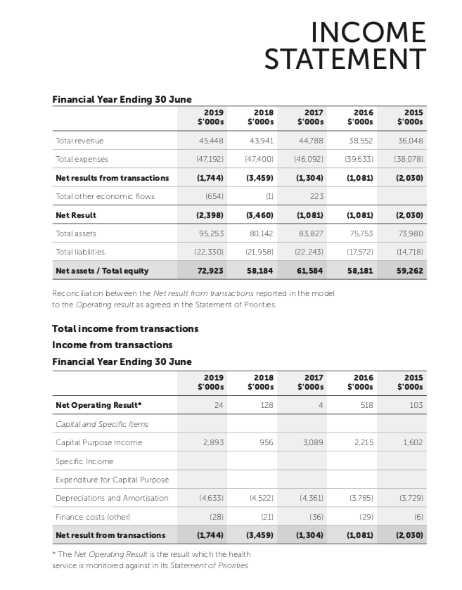

Extract from 2018/19 Annual Report

Organisational Chart

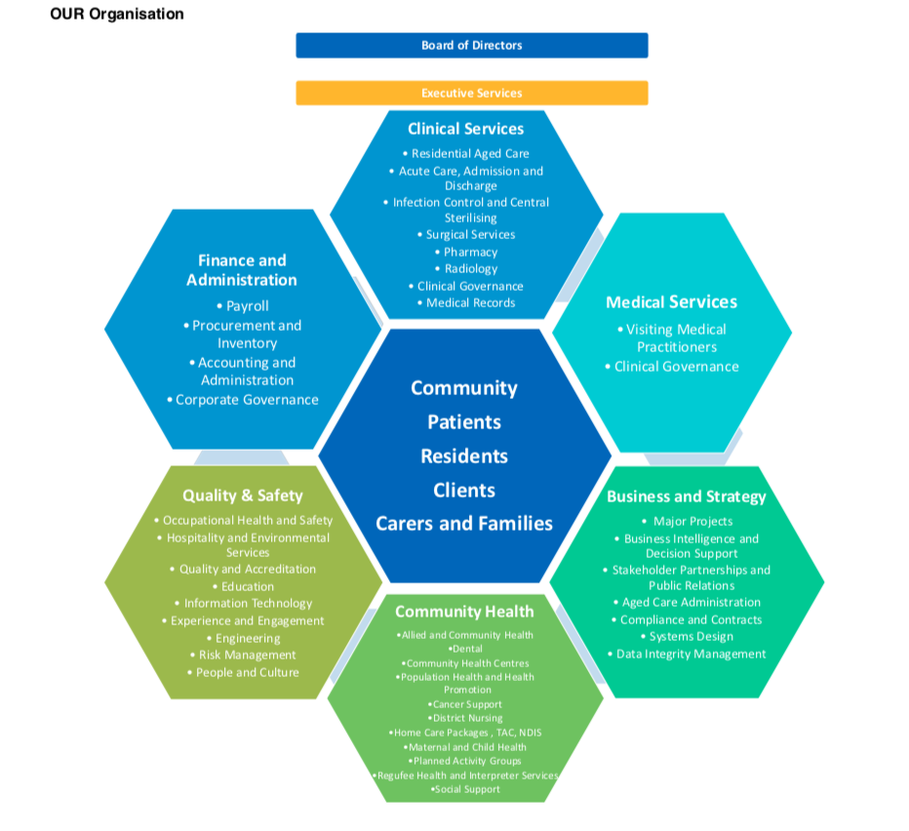

Executive Director of Clinical Services

Position Overview:

The Executive Director of Clinical Service assumes full functional responsibility for acute hospital inpatient and residential aged care related clinical services provided out of the Service’s Nhill, Jeparit, Kaniva, Rainbow, Natimuk and Rupanyup campuses.

Specifically, the Executive Director of Clinical Services is to:
- Lead the clinical services team (comprised of residential aged care, acute hospital and surgical care, and ancillary hospital services) to provide safe, effective and patient‐centred care at all times.
- Participate as an effective team member within the executive team at West Wimmera Health Service.
- Provide appropriate and responsive direction to the Clinical Operations Manager.
- Advise and monitor on personnel functions within the Clinical Division in collaboration with the management team and other relevant departments across all campuses.
- Develop and monitor all aspects of the Clinical Services Division budget in collaboration with the Executive Director of Finance and Administration.
- Ensure that quality systems related to all relevant quality and safety accreditation requirements are in place and monitored, in collaboration with the Executive Director of Quality and Safety.
- Ensure the application of the Service’s Risk Management Framework so that relevant risks are identified, assessed and appropriately controlled.

Key responsibilities:
- To effectively and efficiently oversee the safe, effective and person‐centred provision of clinical services throughout West Wimmera Health Service.
- To act as the principal advisor to the Chief Executive Officer on all matters relating to the provision of clinical services across the Service.
- To enhance organisational capability to address current and future clinical needs of clients.
- To strengthen relationships with internal and external stakeholders, including Visiting Medical Officers, to enhance the organisation’s capacity to meet the need of the community and ensure business viability.

Key Selection Criteria

Essential:
- Demonstrated track record of delivering care that is safe, effective and person‐centred, always.
- Excellent communication, report writing and organisational skills.
- Working knowledge of financial management imperatives in a clinical setting.
- At least 5 years experience in a senior leadership role.
- Sound understanding of quality improvement and accreditation systems.
- Worker screening clearance – police check, working with children check and DWES (Disability Worker Exclusion Scheme check) (Current Flu Vaccination)
- Registered Nurse with APHRA registration.
- Current Victorian Driver’s License.
Desirable:
9. Relevant management qualifications and/or willingness to undertake further study.

Remuneration

The role is full time.

The salary for the position is dependent on qualifications and experience and is subject to the Victorian Public Health Sector Executive Remuneration Policy.

Additional benefits include:
- Salary packaging available
- Relocation assistance by negotiation
- Car – fully maintained vehicle

How to Apply

Applications should include a:

- Covering Letter that also briefly addresses the Key Selection Criteria;
- Current CV and
- Completed Application Form (available on the HRS web site).

Applications can be lodged online via the HRS web site or by email at hrsa@hrsa.com.au

Applications Close: 26 July, 2020

Further Information

Jo Lowday

Director

Health Recruitment Specialists

0400 158 155

